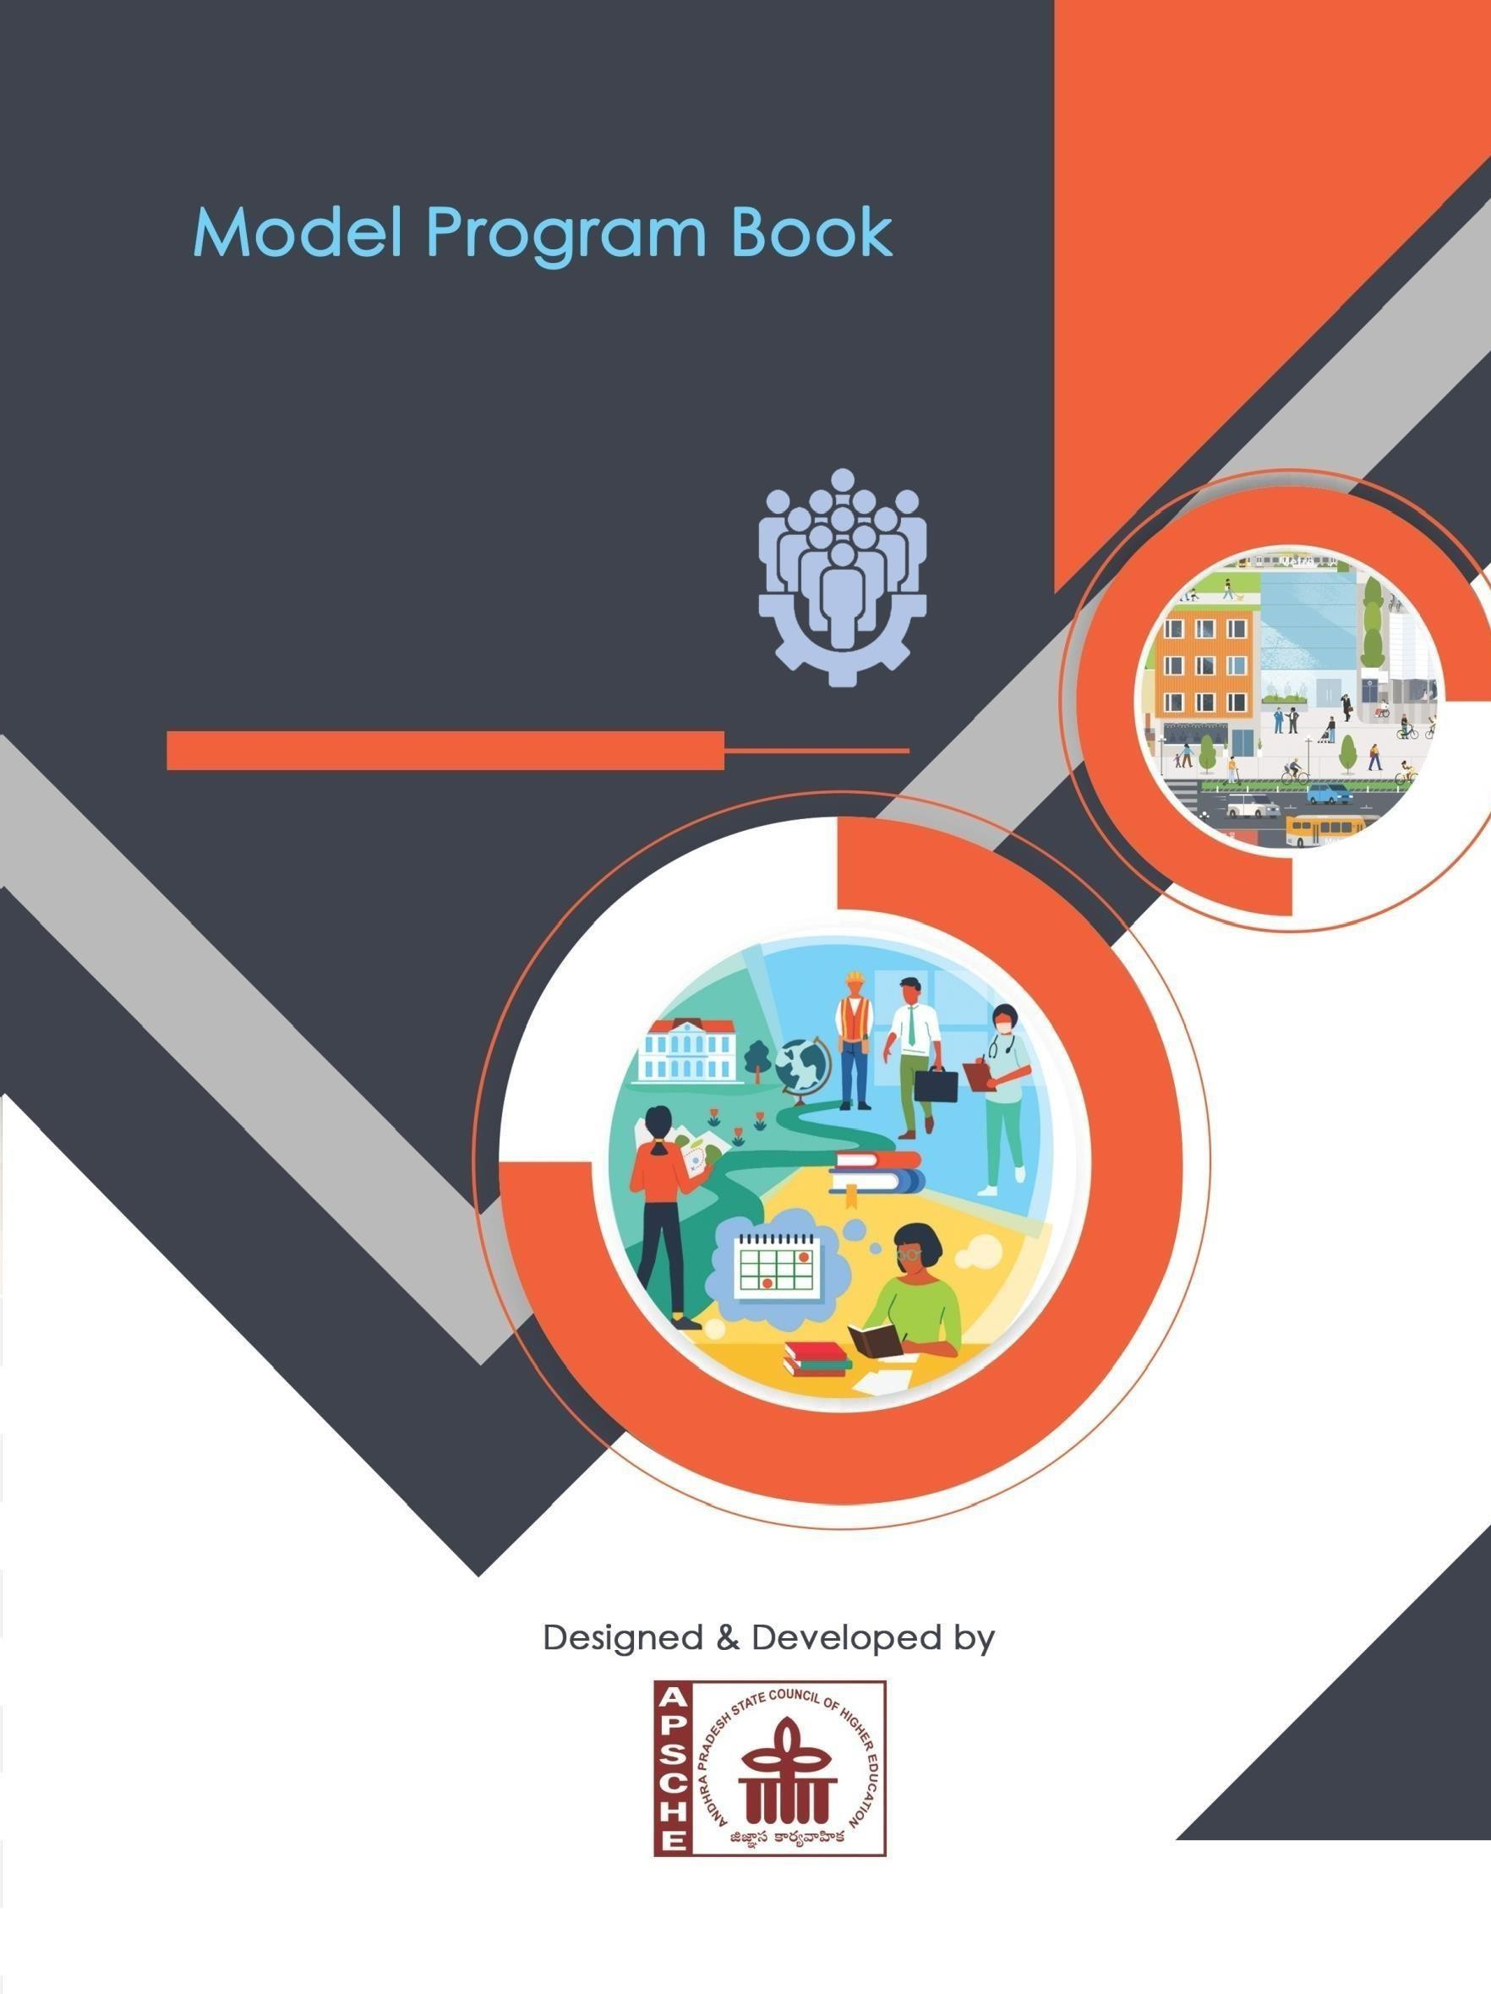
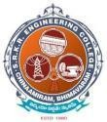
S.R.K.R ENGINEERING COLLEGE (AUTONOMOUS)
(Approved by AICTE, New Delhi, AfFiliated to JNTUK, Kakinada) Accredited by NAAC with ‘A+’ Grade
Recognized as ScientiFic and Industrial Research Organization SRKR MARG, CHINA AMIRAM, BHIMAVARAM-534204, W.G.Dt., A.P., INDIA

COMMUNITY SERVICE INTERNSHIP
B.TECH (R23-Regulation)

ANDHRA PRADESH STATE COUNCIL OF HIGHER EDUCATION
(A STATUTORY BODY OF GOVERNMENT OF ANDHRA PRADESH)

PROGRAM BOOK FOR COMMUNITY SERVICE INTERNSHIP

NAME OF THE STUDENT :S.Guna Sekhar,T.Kailash Prasanth,T.Abhinav,T.Sri Yaswanth
Chowdary,T.Rohith,T.J.V.Sai Kumara Reddy,T.Venkat Lakshmi,T.Dattu Prasanna,T.Navya Sri,T.Praveena Niharika,T.S.S.S Ravi Lokesh

REGISTRATION NO. : 23B91A05S3, 23B91A05S4, 23B91A05S5,
23B91A05S6, 23B91A05S7, 23B91A05S8,
23B91A05S9, 23B91A05T0, 23B91A05T1,
23B91A05T2, 23B91A05T3
PERIOD OF CSP :(PHASE-1) FROM: -00-05-2025 TO: 00-06-2025
(PHASE-2) FROM: 00-06-2025 TO: 00-07-2025

NAME & ADDRESS OF THE COMMUNITY/HABITATION: Pedamiram, Bhimavaram

JAWAHARLAL NEHRU TECHNOLOGICAL UNIVERSITY, KAKINADA
YEAR: 2025-2026

Community Service Internship Report
Submitted in accordance with the requirement for the degree of B. Tech

Name of the College: S.R.K.R.ENGINEERING COLLEGE (A):: BHIMAVARAM

Department: CSE

Name of the Faculty Guide: Ch.Suma, Assistant Prof., CSE

Duration of the CSP:( PHASE-1) FROM: 00-05-2025 TO: 00-06-2025
(PHASE-2) FROM: 00-06-2025 TO: 00-07-2025
Name of the Student:.S.Guna Sekhar,T.Kailash Prasanth,T.Abhinav,T.Sri
Yaswanth Chowdary,T.Rohith,T.J.V.Sai Kumara Reddy,T.Venkat Lakshmi,T.Dattu Prasanna,T.Navya Sri,T.Praveena Niharika,T.S.S.S Ravi Lokesh
Programme of Study: CSE
Year of Study: 2025-2026
Register NO. : 23B91A05S3, 23B91A05S4, 23B91A05S5,23B91A05S6, 23B91A05S7, 23B91A05S8,23B91A05S9, 23B91A05T0,
23B91A05T1,23B91A05T2, 23B91A05T3
Date of Submission:

Student’s Declaration

I, S. Guna Sekhar, T. Kailash Prasanth, T. Abhinav, T. Sri Yashwanth Chowdary, T. Rohith, T. Sai Kumara Reddy, T. Venkata Lakshmi, T. Dattu Prasanna, T. Navya Sri, T. Praveena Niharika, T. Ravi Lokesh] a student of CSE Program Regd.No 23B91A05S3, 23B91A05S4,23B91A05S5,23B91A05S6,23B91A05S7,23B91A05S8,23B91A05S9,
23B91A05T0,23B91A05T1,23B91A05T2,23B91A05T3 of the Department of CSE,
S.R.K.R.ENGINEERING COLLEGE(A )do here by declare that I have completed the mandatory community service from to. in Pedamiram,Bhimavaram (Name of the Community/Habitation) under the Faculty Guideship of Ch.Suma, Assistant Prof., (Name of the Faculty Guide), Department of CSE in S.R.K.R.ENGINEERING COLLEGE (A).

(Signature and Date)
Endorsements

Faculty Guide Head of the Department

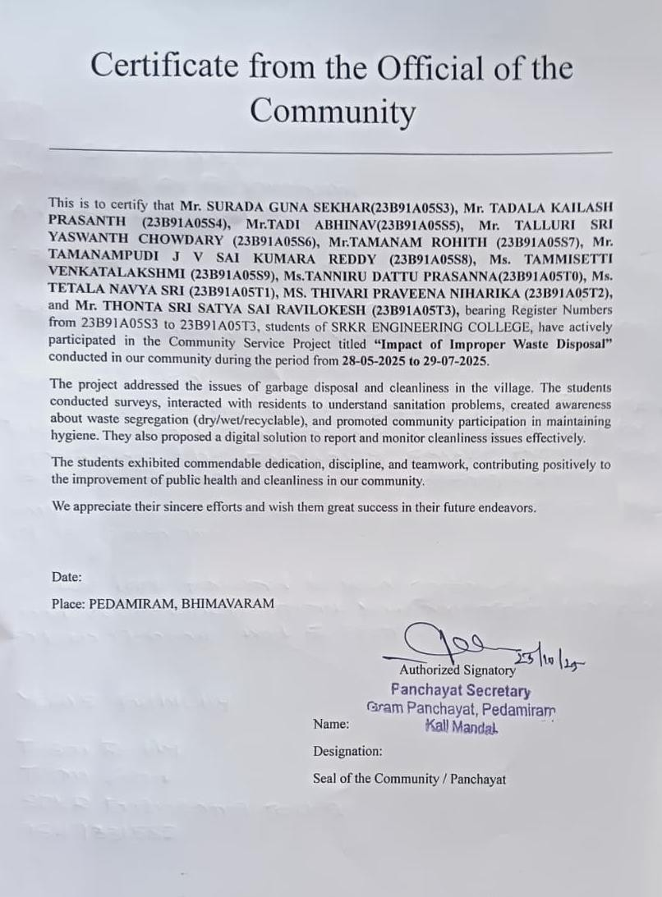

Acknowledgements

I would like to express my heartfelt gratitude to everyone who supported and guided me during the successful completion of my Community Service Project titled “ “Impact of Improper Waste Disposal”.
I am deeply thankful to the management and faculty of
SRKR ENGINEERING COLLEGE for providing me with the opportunity to undertake this socially impactful initiative as part of the Community Service Project. I am especially grateful to my faculty mentor, Sri Ch.Suma, for their continuous encouragement, valuable suggestions, and timely guidance.
My sincere thanks to the local community, especially Pedamiram, Bhimavaram Panchayat ofFicials, Sarpanch,Secretary and residents, for their warm cooperation, valuable insights, and enthusiastic participation throughout the project.
Lastly, I extend my appreciation to my fellow teammates for their dedication, collaboration, and team spirit, which were crucial to the successful implementation of this project.
This experience has been enriching and has instilled in me a strong sense of social responsibility, empathy, and civic awareness.

Date:
Place: Bhimavaram Signature of the Student

Contents
Chapter No. | Details of the chapter | Page No.
1 | Executive Summary | 1
2 | Overview of the Community | 2
3 | Community Service Part | 3
4 | Activity Log for First Week | 4
 | Weekly Report–Week 1 | 5
 | Activity Log for Second Week | 6
 | Weekly Report–Week 2 | 7
 | Activity Log for Third Week | 8
 | Weekly Report–Week 3 | 9
 | Activity Log for Fourth Week | 10
 | Weekly Report–Week 4 | 11
 | Activity Log for Fifth Week | 12
 | Weekly Report–Week 5 | 13
 | Activity Log for Sixth Week | 14
 | Weekly Report–Week 6 | 15
 | Activity Log for Seventh Week | 16
 | Weekly Report–Week 7 | 17
 | Activity Log for Eighth Week | 18
 | Weekly Report–Week 8 | 19
5 | Outcomes Description | 20-30
6 | Recommendations and Conclusions | 31
7 | Student Self Evaluation | 32-42
8 | Evaluation by the Person –in Charge in Community | 43-53
9 | Photos and Video links | 54-56

CHAPTER1: EXECUTIVE SUMMARY

This Community Service Project focused on addressing the issue of improper waste disposal in the local community. The community suffers from persistent garbage piles, stagnant water, and inadequate sanitation infrastructure that contribute to serious health hazards such as mosquito-borne diseases including Dengue and Malaria. These environmental and health challenges are exacerbated by insufficient waste bins, irregular municipal waste collection, and lack of awareness about responsible waste management.

During the project period, various activities were conducted including door-to- door surveys of 120 households and stakeholders, awareness campaigns, cleanliness drives, and consultations with local authorities. These efforts aimed to map problem areas, educate residents on waste segregation and health impacts, and advocate for improved municipal services.

The five key learning objectives and outcomes achieved through this project include:
- Understanding the health and environmental risks of improper waste disposal.
- Engaging and mobilizing community members for sustained cleanliness and sanitation efforts.
- Conducting effective data collection and analysis through field surveys to inform interventions.
- Building collaboration with local governance bodies to improve waste management infrastructure.
- Promoting behavior change towards responsible waste segregation, reduction, and reporting mechanisms.

This project contributed to multiple Sustainable Development Goals, notably ensuring good health and well-being, clean water and sanitation, sustainable cities and communities, and responsible consumption and production, thus fostering a healthier and more sustainable community environment.

CHAPTER 2: OVERVIEW OF THE COMMUNITY

The community where this project was conducted is situated in Pedamiram, a habitation under the Peda Amiram Panchayat in West Godavari District, Andhra Pradesh, India. Historically, this community has maintained a rural lifestyle deeply rooted in local traditions, ethics, and values emphasizing social cohesion, respect for elders, and collective responsibility. The residents have diverse socio-cultural backgrounds, with a combination of agricultural families, small shopkeepers, and daily wage laborers contributing to the local economy.

Community traditions are characterized by close-knit family structures, community festivals, and shared practices that foster mutual support and cooperation. Ethics and values in the community prioritize cleanliness and respect for shared public spaces, though challenges have arisen due to urbanization pressures and inadequate infrastructure.

Socio-economically, the community is predominantly middle to lower- middle class. Agricultural activities remain the primary livelihood for a significant portion of the population, supplemented by small-scale trade and labor in nearby towns. The socio-economic conditions are marked by limited access to modern sanitation facilities, irregular waste management services, and relatively low literacy levels that collectively impact the community's health and well-being.

Despite these challenges, the community exhibits strong social bonds, which were leveraged during the project to promote participation in cleanliness drives, waste management awareness, and health education. This socio-economic context underscores the importance of targeted interventions addressing both infrastructure gaps and behavior change to improve living conditions sustainably.

CHAPTER 3 : COMMUNITY SERVICE PART

During the Community Service Project, a series of meaningful activities were undertaken to address the issue of improper waste disposal in the community. The activities included a comprehensive door-to-door survey covering around 120 households, shopkeepers, municipal workers, and community leaders. This survey gathered critical data on waste accumulation points, sanitation challenges, health hazards due to mosquito breeding, and residents' awareness about waste management.
Following the survey, awareness campaigns were organized to educate community members about the health risks of improper waste disposal, the importance of waste segregation, and the benefits of clean surroundings. Engagements included group discussions, poster distributions, and interactive sessions aimed at mobilizing residents and local stakeholders for regular cleanliness drives.
Clean-up drives were systematically planned and executed to physically reduce garbage piles and stagnant water areas that breed mosquitoes. Students collaborated with municipal staff and community volunteers, further strengthening local commitment to sanitation.
Regular advocacy meetings with panchayat and municipal officials were held to communicate survey findings and push for improvements in sanitation infrastructure, including increasing the number of waste bins and optimizing garbage collection schedules.
This project enabled the student to acquire valuable life skills such as effective communication, teamwork, leadership, and community engagement. Technically, the student gained practical experience in survey design and data collection, problem analysis, campaign planning, and project reporting. The process also instilled important values like social responsibility, empathy towards community health, environmental stewardship, and the power of collective action.

ACTIVITY LOG FOR THE FIRST WEEK

Day & Date |  | Brief description of the daily activity | Learning Outcome | Person In- Charge Signature
 | Day 1  28-05-2025 | Met mentor for initial briefing about the project "Impact of Improper Waste Disposal." Finalized topic focus. | Understood project scope and defined focus area.
Day-2  29-05-2025 |  | Designed survey questionnaire on waste disposal, health, and sanitation infrastructure. | Developed skills in survey design and data collection methods.
 | Day 3  30-05-2025 | Team discussion on field visit strategy, stakeholder list, and location mapping. | Enhanced teamwork and planning skills.
 | Day 4  31-05-2025 | Collected feedback on survey form from mentor, made necessary changes. | Improved attention to detail and quality control.
 | Day 5  02-06-2025 | Printed survey forms and informed local residents about upcoming visits. | Learned community communication and preparation
Day - 6  003-06-2025 |  | Distributed preliminary sample forms and oriented team for data collection. | Gained experience in team coordination and briefing.

WEEKLY REPORT

Week-1(From 28-05-2025to 03-06-2025)

Objective of the Activity Done:
To finalize the project scope and objectives focusing on the health and environmental impacts of improper waste disposal. The week’s tasks included developing the survey questionnaire and planning fieldwork for data collection.

Detailed Report:
The first week was dedicated to laying the groundwork for the Community Service Project on improper waste disposal. The team met with the faculty mentor to receive initial guidance and finalize the project topic. A comprehensive survey questionnaire was designed to collect data on waste disposal habits, sanitation infrastructure, and health impacts within the community. Discussions among team members helped finalize the field visit strategy, including the list of stakeholders and mapping survey locations. The survey tool was submitted for mentor feedback, followed by necessary revisions.
Preparations were made for the upcoming data collection phase by printing survey forms and informing community members about the project. This phase helped the team develop organizational, planning, and communication skills crucial for successful community engagement.

ACTIVITY LOG FOR THE SECOND WEEK

Day & Date | Brief Description of the Daily Activity | Learning Outcome | Person In- Charge Signature
Day -1  04-06-2025 | Conducted door-to-door surveys in the first assigned locality with good resident participation. | Developed field survey skills and community interaction.
Day -2  05-06-2025 | Completed surveys at commercial/market spots; data collected from shopkeepers. | Gained experience in handling diverse respondent groups.
Day -3  06-06-2025 | Interacted with municipal workers regarding waste collection routines; gathered practical operational insights. | Acquired knowledge on municipal solid waste management.
Day -4  07-06-2025 | Documented observations of garbage piles, bins, and stagnant water; took photographs for documentation. | Learned documentation and evidence collection methods.
Day -5  09-06-2025 | Compiled survey responses and summarized key findings; initiated summary preparation. | Enhanced analytical and reporting skills.
Day -6  10-06-2025 | Analyzed infrastructure gaps and most- reported health hazards; completed initial data analysis. | Gained insights on data interpretation in community health.

WEEKLY REPORT

Week-2(From 04-06-2025to 10-06-2025)

Objective of the Activity Done:
To conduct detailed field surveys in the assigned locality, gather comprehensive data from residents, shopkeepers, and municipal workers about waste disposal and sanitation issues, and begin preliminary analysis of collected information.

Detailed Report:
During the second week, the project team conducted extensive door-to-door surveys within the community, engaging with households and commercial establishments to understand waste generation, disposal practices, and prevalent health concerns resulting from improper sanitation. The survey collected valuable data on the frequency of garbage collection, existing infrastructure for waste management, and community awareness regarding health risks such as mosquito-borne diseases.
In addition to resident surveys, interactions with municipal workers provided practical insights into waste collection challenges and operational routines.
The team diligently documented observations of garbage sites, bins, and stagnant water bodies, supporting field data with photographic evidence. Following data collection, the team compiled survey responses and began a thorough analysis to identify critical gaps in infrastructure and common health hazards reported by the community. This preliminary evaluation guided the drafting of actionable problem lists and informed plans for targeted awareness campaigns and intervention strategies.
The week concluded with submission of the progress report to the faculty mentor, highlighting key findings, challenges faced during fieldwork, and the next steps to enhance outreach and community engagement efforts.

ACTIVITY LOG FOR THE THIRD WEEK

Day | Brief Description of the Daily Activity | Learning Outcome | Person In- Charge Signature
Day -1  11-06-2025 | Extended survey area to cover new neighborhoods and local public spaces. | Expanded understanding of community dynamics and spatial data.
Day -2  12-06-2025 | Held focused discussions with elderly residents and sanitation workers to gather detailed insights. | Improved communication and qualitative data gathering skills.
Day -3  13-06-2025 | Identified recurring pollution types such as solid waste, water stagnation, and animals. | Enhanced analytical skills in categorizing community issues.
Day -4  14-06-2025 | Grouped survey responses to reveal common themes like disease prevalence, infrastructure gaps, and awareness levels. | Strengthened data synthesis and theme identification abilities.
Day -5  16-06-2025 | Drafted a prioritized list of actionable problems and brainstormed possible solutions. | Developed problem- solving and strategic planning skills.
Day -6  17-06-2025 | Prepared a weekly summary and updated the faculty mentor about emerging trends and progress. | Improved reporting and presentation skills.

WEEKLY REPORT

Week-3(From 11-06-2025to 17-06-2025)

Objective of the Activity Done:
To expand the survey coverage to additional neighborhoods and public spaces, gather qualitative insights through focused discussions, identify key pollution issues, and begin synthesizing data to prioritize community problems
.

Detailed Report:
In the third week of the Community Service Project, the team extended field surveys beyond the initial areas to include new neighborhoods and frequently accessed public spaces. This broadened reach was essential to capture diverse waste management and sanitation challenges across the community.
Focused discussions were held with elderly residents and sanitation workers to gather detailed stories and contextual insights that quantitative surveys alone could not reveal. These interviews enriched understanding of long- standing issues and community perceptions regarding sanitation and health. The team systematically identified recurring types of pollution, including solid waste accumulation, stagnant water, and the presence of animals contributing to health risks. Grouping survey responses helped to reveal common themes relating to disease spread, infrastructure gaps, and the level of community awareness on sanitation matters.
Using these synthesized findings, the team drafted a prioritized list of actionable problems and brainstormed possible interventions tailored to the community's needs. Regular updates and peer reviews within the team ensured that data gaps were addressed and next steps refined.
This week bolstered the team's analytical and communication skills while reinforcing the importance of inclusive community engagement for effective problem-solving.

ACTIVITY LOG FOR THE FORTH WEEK

Day | Brief Description of the Daily Activity | Learning Outcome | Person In- Charge Signature
Day -1  18-06-2025 | Planned awareness sessions and poster campaign design; mentor approved content. | Developed skills in campaign planning and content creation.
Day -2  20-06-2025 | Created and printed posters and charts on waste segregation and hygiene; finalized materials. | Enhanced visual communication and material preparation skills.
Day -3  21-06-2025 | Shared campaign plan with panchayat and secured approval; gained local support. | Learned stakeholder engagement and advocacy strategies.
Day -4  23-06-2025 | Distributed posters and delivered group talks in outdoor institutions; engaged residents. | Improved public speaking and community mobilization skills.
Day -5  25-06-2025 | Collected informal feedback from participants; noted and analyzed responses. | Enhanced feedback collection and analysis abilities.
Day -6  27-06-2025 | Documented session attendance and observed behavior change; recorded attendance. | Gained observation skills and data recording accuracy.

WEEKLY REPORT

Week-4(From 18-06-2025to 27-06-2025)

Objective of the Activity Done:
To implement and monitor sanitation awareness campaigns within the community, utilizing various communication tools and organized sessions to educate residents about waste segregation, hygiene, and health risks related to improper waste disposal.

Detailed Report:
In the fourth week, the team focused on raising community awareness about the critical importance of sanitation and hygiene. This was achieved through carefully planned awareness sessions and the design of educational poster campaigns. After gaining mentor approval, the team created and distributed posters and charts illustrating proper waste segregation and hygiene practices. The campaign plan was shared with the local panchayat, securing their support and collaboration to maximize outreach. Posters were placed at strategic locations, and group talks were conducted at outdoor community institutions, attracting active participation from residents.
Informal feedback was continuously gathered from participants to assess the effectiveness of the campaign, providing valuable insights for improvement. Attendance and engagement were meticulously documented, allowing the team to observe positive behavioral changes and enhanced awareness levels within the community.
This week’s activities strengthened the team's abilities in community mobilization, visual communication, and feedback management, all crucial to sustaining long-term sanitation improvements.

ACTIVITY LOG FOR THE FIFTH WEEK

Day & Date |  | Brief description of the daily activity | Learning Outcome | Person In- Charge Signature
 | Day 1  28-06-2025 | Follow-up visits to households to check adoption of waste segregation and hygiene lessons from previous campaigns. | Understood the rate of behavioral change among residents..
Day-2  30-06-2025 |  | Gathered feedback from community members regarding improvements in cleanliness and waste disposal routines. | Improved listening and evaluation skills.
 | Day 3  01-07-2025 | Documented positive changes with photographs, focused on identified problem areas and solutions implemented. | Learned hands-on documentation and evidence collection.
 | Day 4  02-07-2025 | Conducted small refresher sessions for new or absent residents, shared success stories to motivate others. | Enhanced outreach and peer-to-peer learning techniques.
 | Day 5  03-07-2025 | Met with local officials/municipal workers to update data and discuss any ongoing challenges. | Strengthened liaison and advocacy skills.
Day- 6  04-07-2025 |  | Analyzed all feedback and prepared a brief weekly summary of changes noted and areas needing further attention. | Analyzed all feedback and prepared a brief weekly summary of changes noted and areas needing further attention.

WEEKLY REPORT

Week-5(From 28-06-2025 to 04-07-2025)

Objective of the Activity Done:
The main objective of the fifth week’s activities was to follow up with the community members to assess and reinforce the behavioral changes promoted during earlier campaigns on proper waste disposal and hygiene practices. This included conducting home visits, collecting feedback on progress and challenges, documenting improvements, organizing refresher awareness sessions for new or absent participants, and collaborating with local authorities to address persistent issues in waste management. These activities aimed to ensure sustained adoption of best practices, gather evidence of impact, and plan further interventions to achieve long-term improvements in community health and sanitation.

Detailed Report:
During the fifth week, the project focused on following up with community members to assess how well awareness about proper waste disposal and hygiene was being implemented. The team conducted home visits to observe practices and provided additional guidance where needed to encourage adherence to recommended behaviors.
Community feedback was actively collected to understand the successes and challenges faced by residents. Many reported improvements in waste segregation and cleanliness, while some highlighted issues with irregular municipal waste collection and insufficient availability of dustbins.
Refresher awareness sessions were organized for residents who missed previous campaigns or needed further motivation. These sessions reinforced the importance of maintaining clean surroundings and proper waste management to prevent health hazards.
The team also collaborated closely with local authorities to share feedback and advocate for practical solutions to ongoing problems. These combined efforts helped strengthen community participation and foster continuous improvement in local sanitation practices.

ACTIVITY LOG FOR THE SIXTH WEEK

Day & Date |  | Brief description of the daily activity | Learning Outcome | Person In- Charge Signature
 | Day 1  05-07-2025 | Follow-up visit to community areas to assess continued waste segregation. | Understood progress of behavioral change.
Day-2  07-07-2025 |  | Conducted awareness sessions for new community members. | Improved community participation and knowledge.
 | Day 3  08-07-2025 | Collaborated with municipality to address garbage collection issues. | Strengthened link between community and officials.
 | Day 4  09-07-2025 | Documented ongoing challenges and success stories | Enhanced skills in data collection and reporting
 | Day 5  10-07-2025 | Organized community feedback meeting. | Developed communication and analytical skills.
Day- 6  11-07-2025 |  | Prepared summary of week’s activities and observations. | Improved reporting and documentation skills.

WEEKLY REPORT

Week-6(From 05-07-2025to 11-07-2025)

Objective of the Activity Done:
The main objective of the sixth week was to continue strengthening the community's involvement in proper waste disposal and hygiene practices by expanding awareness efforts to new residents and reinforcing learning with existing participants. This involved collaboration with local municipal authorities to address infrastructural challenges like garbage collection. The activities aimed to monitor ongoing improvements, document progress, identify persisting gaps, and promote sustainable waste management behaviors for long-term community health enhancement.

Detailed Report:
In the sixth week of the project, the focus was on extending the impact of previous waste management awareness campaigns by reaching out to new community members and reinforcing the practices among earlier participants. The team conducted awareness sessions and follow-up visits to ensure consistent adoption of waste segregation and hygiene behaviors throughout the community.
Collaborative efforts with local municipal workers were emphasized to address logistical challenges such as irregular garbage collection and inadequate waste bin availability. Meetings were held to communicate community feedback and discuss practical improvements that could be implemented to support the residents in maintaining cleanliness.
Documentation continued through data collection, photographing success stories, and recording ongoing challenges. These measures helped in effective monitoring and served as evidence for the sustained engagement of the community in the project activities.
By the end of the week, the team consolidated all observations into a comprehensive summary report for review. The continuous dialogue between the community, project team, and municipal authorities was vital in reinforcing positive behavioral changes and planning further interventions for better waste management and public health outcomes.

ACTIVITY LOG FOR THE SEVENTH WEEK

Day & Date | Brief description of the daily activity | Learning Outcome | Person In- Charge Signature
Day-1  12-07-2025 | Follow-up with households to monitor continued waste management practices. | Gained insight into sustained behavioral changes in the community.
Day-2  14-07-2025 | Conducted refresher awareness sessions for new and previously unengaged members. | Enhanced community knowledge and participation.
Day-3  15-07-2025 | Assessed utilization and maintenance of newly installed waste bins. | Improved skills in infrastructure usage assessment.
Day-4  16-07-2025 | Compiled data on changes in garbage collection and community cleanliness. | Enhanced reporting and data synthesis capabilities.
Day-5  17-07-2025 | Met with local government officials to discuss feedback and project challenges. | Strengthened advocacy and stakeholder communication.
Day-6  18-07-2025 | Prepared a comprehensive weekly summary and strategy for the next phase. | Boosted planning and documentation abilities.

WEEKLY REPORT

Week-7(From 12-07-2025 to 18-07-2025)

Objective of the Activity Done:
The primary objective of the seventh week was to ensure the sustained adoption of improved waste management practices across the community. This was achieved through rigorous follow-ups with households, additional awareness sessions for those previously unreached, and continued monitoring of waste infrastructure. Efforts also focused on gathering updated feedback from local stakeholders and further coordinating with municipal authorities to resolve persistent sanitation issues. The team aimed to document ongoing progress, stimulate active participation, and build momentum for future initiatives.

Detailed Report:
During the seventh week, the project team prioritized reinforcing behavioral change by visiting households to assess ongoing waste segregation and cleanliness practices. Special attention was given to members who had missed earlier campaigns by organizing targeted refresher sessions, thereby increasing participation and awareness. The condition and usage of newly installed waste bins were evaluated to measure infrastructure effectiveness and community compliance.
Regular documentation continued through the collection of data on community cleanliness levels and the frequency of garbage collection. Meetings with municipal officials played a crucial role in discussing challenges encountered by both residents and authorities, and in identifying practical solutions for smoother waste management. The feedback and insights gathered guided the planning of subsequent engagement strategies. By the end of the week, the team consolidated findings and prepared an action plan for continuous improvement, keeping community momentum high and ensuring sustained progress toward healthier and cleaner living conditions.

ACTIVITY LOG FOR THE EIGHT WEEK

Day & Date | Brief description of the daily activity | Learning Outcome | Person In- Charge Signature
Day-1  19-07-2025 | Conducted final assessment of cleanliness and waste management levels. | Learned evaluation and impact measurement techniques.
Day-2  21-07-2025 | Collected feedback from community residents and municipal workers. | Enhanced skills in stakeholder engagement and data gathering.
Day-3  22-07-2025 | Organized closing awareness drive and distributed educational materials. | Improved public speaking skills and community outreach.
Day-4  24-07-2025 | Documented success stories and remaining challenges for project summary. | Developed reporting and summarization abilities.
Day-5  25-07-2025 | Submitted final feedback and suggestions to local authorities. | Practiced formal advocacy and communication.
Day-6  26-07-2025 | Compiled and submitted final week’s comprehensive report to mentor. | Strengthened documentation and presentation skills.

WEEKLY REPORT

Week-8(From 19-07-2025 to 26-07-2025)

Objective of the Activity Done:
The main objective of the eighth week was to conduct a comprehensive evaluation of the community sanitation project’s impact and consolidate final feedback from all stakeholders. Emphasis was placed on assessing cleanliness improvements, gauging community satisfaction, and identifying ongoing challenges. The activities aimed to reinforce sustainable practices, celebrate success stories, and finalize the project documentation for submission.

Detailed Report:
In the eighth week, the project team carried out thorough assessments of the overall sanitation and waste management improvements achieved through the previous interventions. Extensive feedback was collected from community members, local municipal workers, and other stakeholders to measure the effectiveness and acceptance of new practices. A closing awareness drive was organized, focusing on sustaining long-term community engagement and hygiene standards.
The team documented success stories alongside persistent challenges to provide a balanced view of project outcomes. Final suggestions and feedback were presented to municipal authorities, fostering ongoing collaboration for continued improvements. The week concluded with the preparation and submission of a detailed final report to the faculty mentor, encapsulating all findings, lessons learned, and recommendations for future initiatives.

CHAPTER 5: OUTCOMES DESCRIPTION

Socio-Economic and Waste Management Survey Questionnaire

Section A: Respondent Information
Name of the Respondent: Age:
Address / Habitation: Occupation:
Family Monthly Income: Family Type:
No. of Family Members:

Section B: Awareness on Waste Disposal and Hygiene
Question Response
Are you aware of the health risks of improper waste disposal? (Yes / No)
How do you dispose of your household waste?
(Open dumping / Burning / Municipal collection) Do you segregate your waste into biodegradable
and non-biodegradable? (Always / Sometimes / Never) How often does municipal waste collection happen
in your area? (Daily / Weekly / Irregular) Have you participated in any community cleanliness drives? (Yes / No)

Section C: Waste Facilities and Services
Question Response

Are waste bins easily accessible in your neighborhood? (Yes / No)

Is the waste bin usage encouraged in your community? (Yes / No)

Are you aware of any government schemes for
waste management in your area? (Yes / No)

Would you support implementation of
better waste disposal infrastructure? (Yes / No)

Section D: Community Participation and Suggestions
Question Response
Have you attended waste management awareness programs? (Yes / No)
What challenges do you face in
maintaining cleanliness at your home or locality?

Suggest ways to improve waste disposal and community sanitation.
Will you encourage neighbors to follow proper waste disposal methods? (Yes / No) Any additional feedback or suggestions regarding community cleanliness?

Section E: Impact of Waste on Health and Environment
Question Response
Have you or anyone in your family
experienced illness due to poor sanitation? (Yes / No) Are you aware of diseases spread by poor waste disposal
practices, such as dengue, malaria? (Yes / No) Has awareness in your community helped reduce health problems? (Yes / No)
Do you think improved waste management will enhance your community’s health? (Yes / No)

Section F: Overall Feedback and Expectations
What kind of support or resources do you expect from local authorities for waste management?
_________________________________________________
List any improvements you would like to see regarding community cleanliness and health.
_________________________________________________
Any other comments or suggestions:
_________________________________________________

Key Problems Identifed:

Action Plan:

Short-Term: Foundation and Insight Generation

Goal: Understand community challenges and build baseline data.

- Conduct door-to-door surveys and focus group discussions to assess waste disposal practices and community awareness.
- Identify critical problem areas like irregular waste collection, garbage accumulation, and health hazards including mosquito breeding.
- Document current waste management infrastructure status and behavioral patterns.
- Launch initial awareness campaigns promoting waste segregation and hygiene in collaboration with local leaders.
- Establish data collection protocols ensuring ethical standards and community engagement.
- Begin building stakeholder partnerships with municipal authorities and community representatives.

Mid-Term: Development and Pilot Implementation

Goal: Develop solutions and test community engagement models.

- Advocate for and facilitate the installation of adequate waste bins and improved municipal garbage collection.

- Organize regular cleanliness drives and targeted educational sessions reinforcing proper waste disposal.

- Pilot behavior change interventions and monitor participation and compliance within the community.

- Train community volunteers and municipal workers for sustained program support.

- Collect feedback and refine awareness materials and intervention methods.

- Strengthen collaboration with local government, NGOs, and health departments for resource pooling and support.

Long-Term: Scale and Sustainability

Goal: Institutionalize waste management practices for lasting impact.

- Formalize community waste management committees to lead ongoing sanitation efforts.

- Establish routine monitoring and reporting systems for waste handling and public health indicators.

- Integrate digital platforms for community reporting and engagement on sanitation issues.

- Expand partnerships with multiple stakeholders for technical, financial, and policy support.

- Promote continuous education, especially among youth and schools, to embed behavioral change.

- Evaluate outcomes regularly against sustainable development goals to ensure environmental and health benefits are maintained.Describe the problems you have identified in the community.

Awareness Campaign Planning & Preparation:
Awareness campaign planning and preparation involve identifying the target audience within the community such as households, local businesses, schools, and municipal workers, setting clear objectives like improving knowledge on waste segregation and participation in sanitation drives, and developing culturally relevant educational materials including posters, flyers, and audio-visual aids. Key stakeholders including local leaders, health workers, and municipal officials are engaged early to build support. Detailed scheduling of sessions, community meetings, and outreach activities ensures maximum participation. Training volunteers and staff to effectively communicate the campaign messages is essential, as is setting up feedback and monitoring mechanisms to evaluate the campaign’s impact and adapt strategies for sustained community engagement and improved sanitation practices.

Campaign 1:Initial Awareness and Empowerment
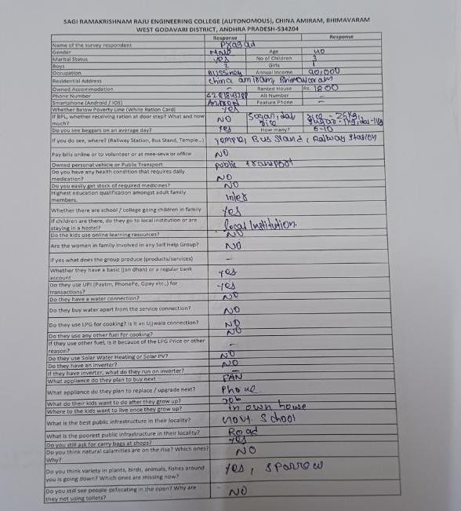
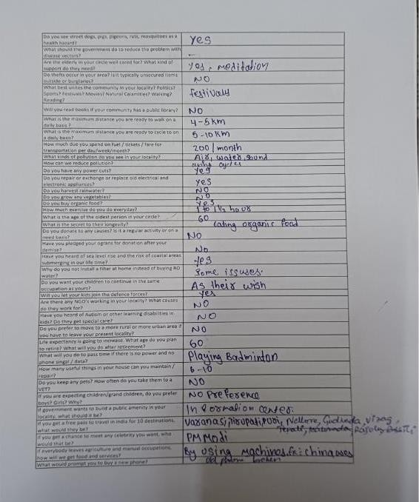
Participants became more aware of waste segregation and proper disposal methods. Many community members were unaware of the health risks associated with improper waste management. This campaign educated them about these risks and motivated them to adopt safer practices, reducing environmental pollution and mosquito breeding sites. The campaign empowered residents to actively participate in cleanliness drives and demanded better municipal services.

Campaign 2: Strengthening Community Engagement and Institutional Linkages
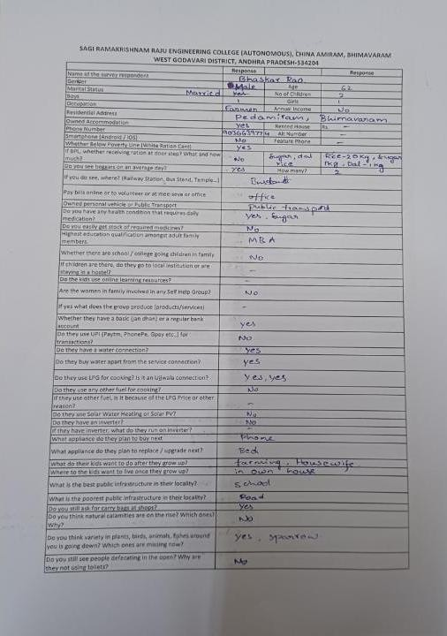
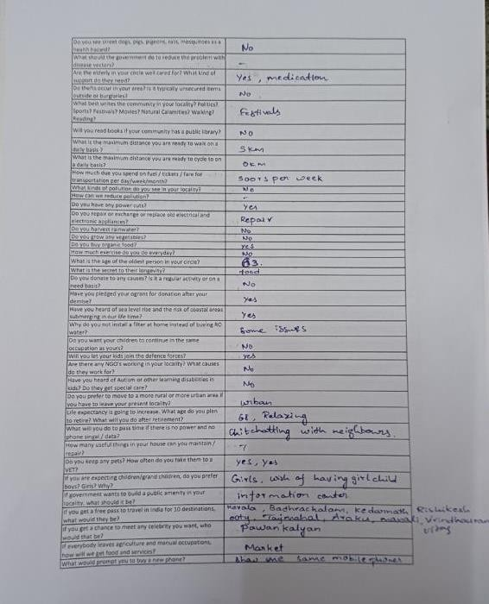

This campaign focused on deepening the community's involvement by engaging local leaders, health workers, and municipal officials.
Participants were educated about government sanitation schemes and services aimed at improving waste management infrastructures, fostering awareness about their entitlements. The campaign introduced tools and channels for reporting sanitation issues, enhancing communication between residents and local authorities. This phase reinforced behavior change, resulting in increased community participation and improved coordination for regular waste collection and environment monitoring.

Campaign 3: Sustaining Impact and Monitoring Progress
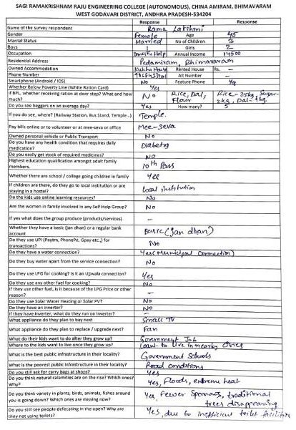
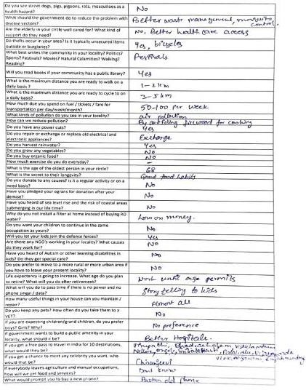

The final campaign emphasized sustaining positive behavior changes and assessing the impact of prior initiatives. Follow-up visits and meetings showcased improvements in local sanitation and community health, encouraging wider compliance. Success stories were shared within the community to inspire continued efforts. Local sanitation committees were strengthened or formed to oversee ongoing activities. The campaign highlighted the importance of continuous vigilance against waste mismanagement and the long-term benefits of cleaner surroundings to public health and the environment.

Overall Outcome:

- Increased community knowledge about waste segregation, proper disposal methods, and environmental health risks.

- Greater engagement with municipal waste management services and active participation in cleanliness campaigns.
- Empowered residents with awareness of government schemes related to

sanitation and health, enabling better access and utilization.

- Strengthened communication channels between community members and local authorities through digital reporting tools.
- Formation of local sanitation committees promoting sustained community-led monitoring and advocacy.
- Noticeable improvement in community hygiene, reduction in garbage accumulation, and decreased incidence of vector-borne diseases.

These campaigns successfully translated awareness into lasting behavior change and institutional collaboration, contributing to improved environmental sustainability and public health aligned with broader development goals.

Report of the mini-project

As part of our Community Service Project, we developed a Web Application titled “Clean My Community”, aimed at promoting cleanliness, waste management, and environmental awareness among residents in Pedamiram village. The goal of this project was to use technology to encourage citizen participation in maintaining clean surroundings, preventing mosquito breeding, and fostering a healthier and more sustainable environment.
In many rural and semi-urban communities, including Pedamiram, improper waste disposal, stagnant water, and low awareness about hygiene contribute to various health and environmental issues. These conditions often lead to mosquito-borne diseases such as dengue and malaria. To address these challenges, our team designed a web-based system that enables local residents to report sanitation issues, share awareness information, and track community clean-up activities.
The application allows users to upload photos of unclean areas or mosquito- prone zones, provide brief descriptions, and submit them for action. These reports can be viewed and managed by volunteers or community representatives for quick response. Additionally, the system includes sections such as an Activity Log and Gallery to showcase awareness programs, clean- up drives, and success stories from Pedamiram. This feature motivates active participation and collective responsibility among community members.
The project was developed using React.js,, HTML, CSS, and JavaScript, providing a responsive, user-friendly interface suitable for all types of
devices. The website’s layout and design were carefully planned to ensure accessibility for people in rural areas, even with limited technical experience. Through this project, we applied our technical knowledge in web development to solve a real-world community issue. More importantly, it gave us the opportunity to work directly with the people of Pedamiram, understand their sanitation-related challenges, and create a platform tailored to their needs. The project enhanced our understanding of social responsibility and the power of technology in improving public health and environmental conditions.
By empowering residents to report issues and participate in clean-up activities, Clean My Community promotes civic awareness and supports public health goals. It also encourages behavioral change by making cleanliness and hygiene a shared responsibility within the community.
This project aligns with the United Nations Sustainable Development Goals (SDGs), specifically:
SDG 3: Good Health and Well-Being
SDG 6: Clean Water and Sanitation
SDG 11: Sustainable Cities and Communities
SDG 12: Responsible Consumption and Production
By combining technology, teamwork, and community awareness, Clean My Community contributes to building a cleaner, healthier, and more sustainable future for Pedamiram village and surrounding areas.

Website Structure:
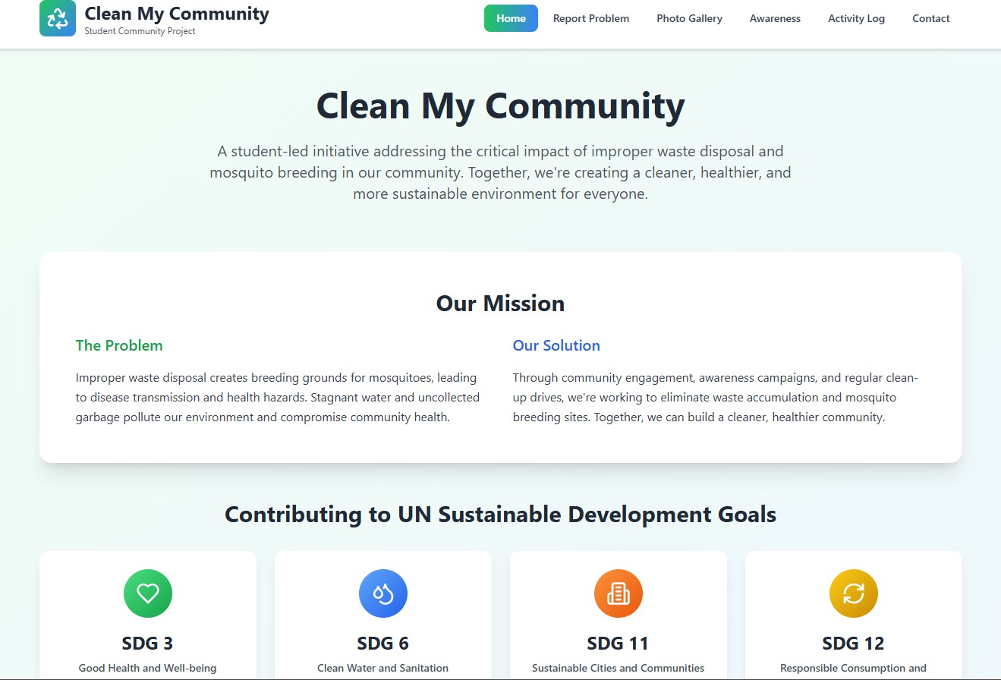

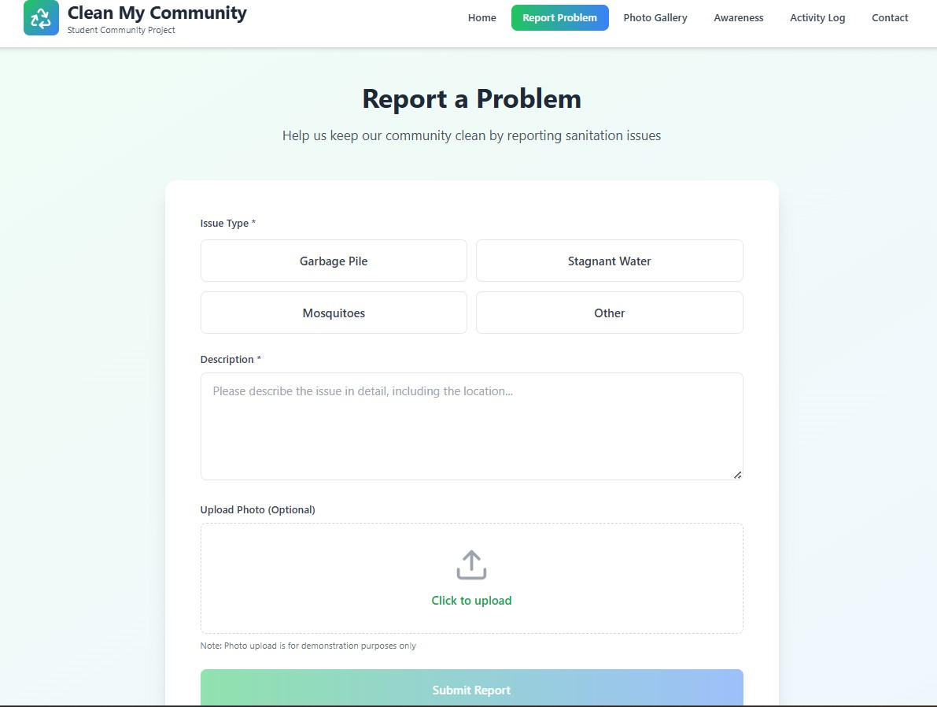

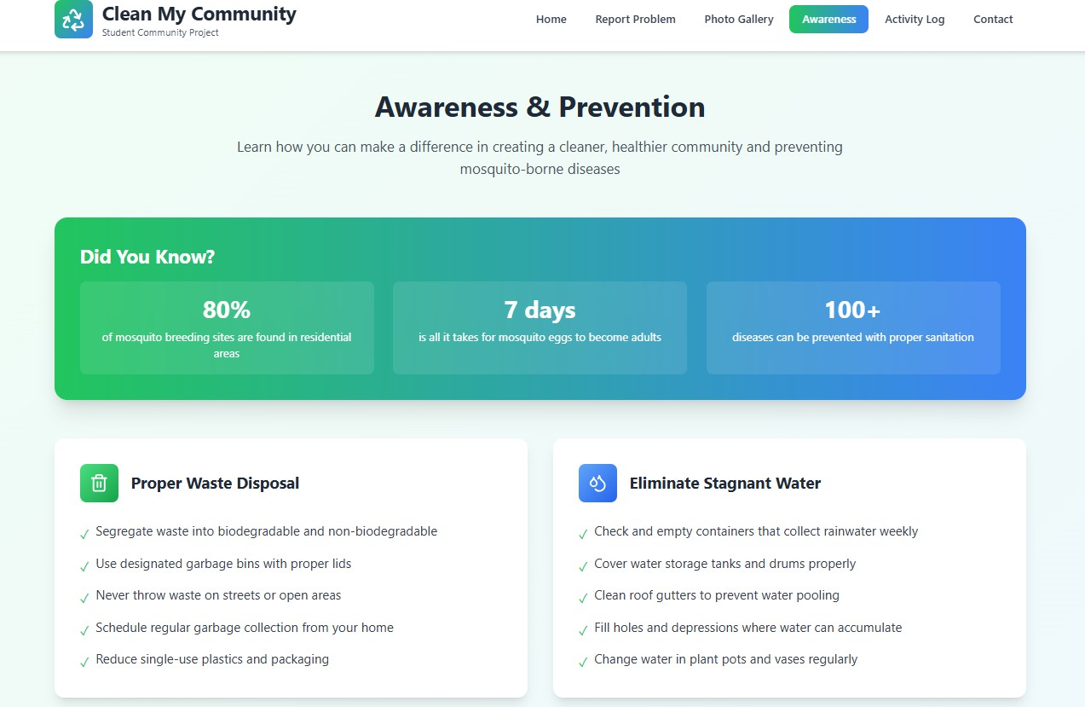

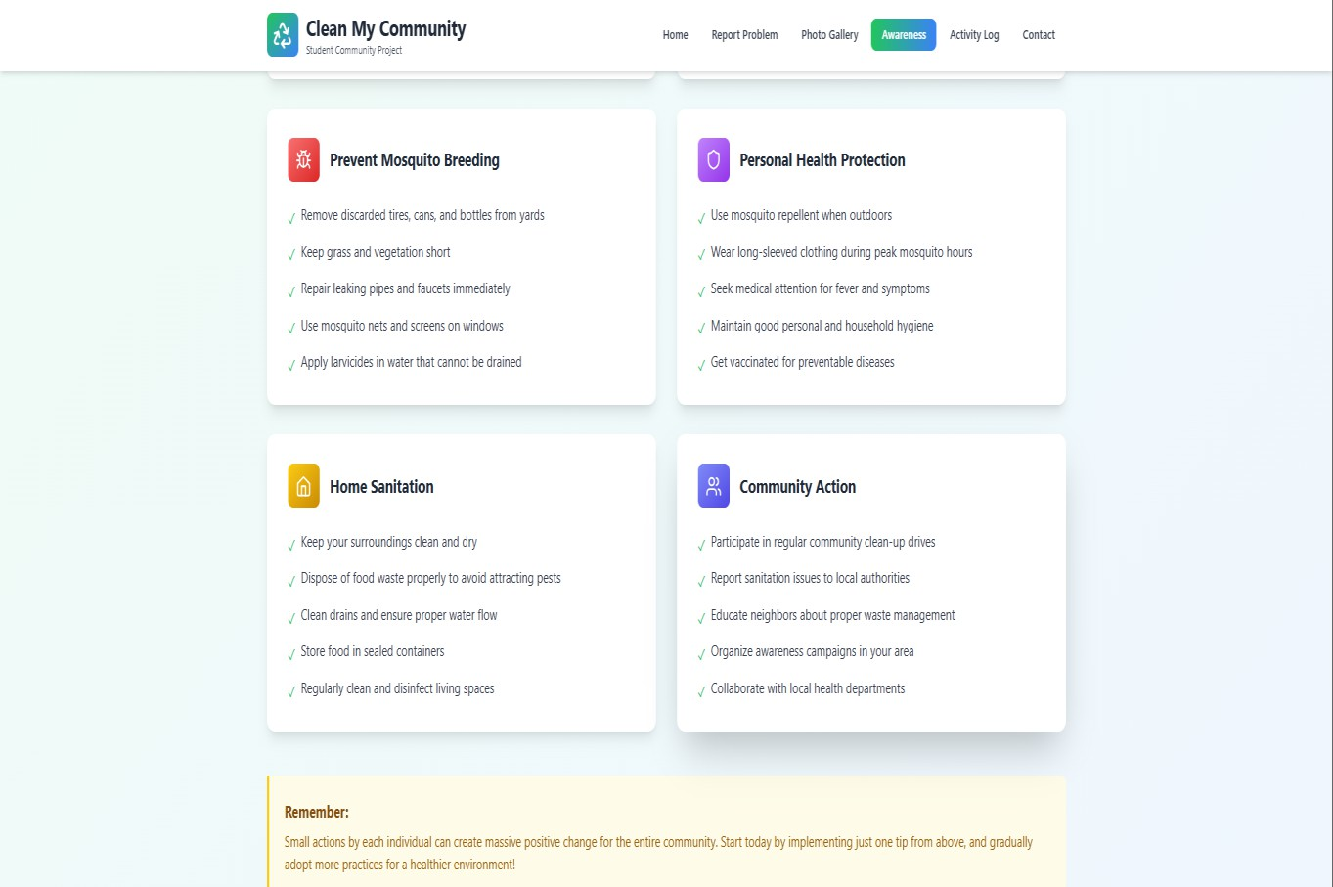

CHAPTER 6: RECOMMENDATIONS AND CONCLUSIONS OF THE MINI PROJECT

Recommendations:
- Strengthen awareness campaigns by collaborating with local health authorities and educational institutions to ensure consistent dissemination of information about proper waste disposal and prevention of mosquito breeding.
- Increase the frequency of community cleanliness drives and introduce a structured mechanism for regular monitoring of sanitation hotspots.
- Expand access to waste collection bins and improve municipal waste management services, focusing especially on vulnerable and underserved regions within the village.
- Implement digital solutions, such as the "Clean My Community" app/website, enabling residents to report sanitation issues, track clean- up activities, and access educational materials easily.
- Organize training sessions for community members and municipal workers to create sustainable habits in segregation, recycling, and safe disposal of waste.
- Foster partnerships with NGOs and government agencies to provide technical and financial support for long-term improvements in sanitation infrastructure.
- Promote student-led initiatives and community service internships as ongoing activities, encouraging youth engagement in solving local health and environmental challenges.

Conclusions:

The Community Service Project has made a significant positive impact on both civic awareness and practical improvement of hygiene standards in the community. Through field surveys, educational campaigns, weekly activity monitoring, and the integration of technology, the project effectively addressed key issues relating to improper waste disposal and the risks of mosquito-borne diseases.
The collaborative approach between students, local authorities, and residents resulted in greater community participation and accountability. The development of a dedicated website further enhanced transparency, engagement, and problem reporting.
The experience provided valuable technical, organizational, and leadership skills to student participants, highlighting the importance of social responsibility and digital literacy in community development.
Sustained commitment and inclusive action are essential for building healthier, safer, and more sustainable communities.

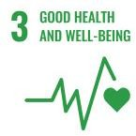
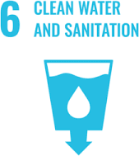
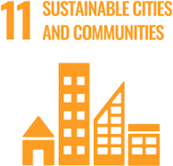
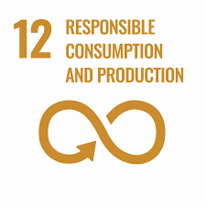

Student Name : S . G u n a S e k h a r
Registration No: 23B91A05S3 Branch: CSE Year/Sem: 3/4 I sem
Period of CSP : From: 28-05-2025 To: 26-07-2025
Date of Evaluation:
Please rate your performance in the following areas:

Rating Scale: Letter grade of CGPA calculation to be provided

1 Oral communication | 1 | 2 | 3 | 4 | 5
2 Written communication | 1 | 2 | 3 | 4 | 5
3 Proactiveness | 1 | 2 | 3 | 4 | 5
4 Interaction ability with community | 1 | 2 | 3 | 4 | 5
5 Positive Attitude | 1 | 2 | 3 | 4 | 5
6 Self-conFidence | 1 | 2 | 3 | 4 | 5
7 Ability to learn | 1 | 2 | 3 | 4 | 5
8 Work Plan and organization | 1 | 2 | 3 | 4 | 5
9 Professionalism | 1 | 2 | 3 | 4 | 5
10 Creativity | 1 | 2 | 3 | 4 | 5
11 Quality of work done | 1 | 2 | 3 | 4 | 5
12 Time Management | 1 | 2 | 3 | 4 | 5
13 Understanding the Community | 1 | 2 | 3 | 4 | 5
14 Achievement of Desired Outcomes | 1 | 2 | 3 | 4 | 5
15 OVERALLPERFORMANCE | 1 | 2 | 3 | 4 | 5

Date: Signature of the Student

Student Name : T. Kailash Prasanth
Registration No: 23B91A05S4 Branch: CSE Year/Sem: 3/4 I sem
Period of CSP : From: 28-05-2025 To: 26-07-2025
Date of Evaluation:
Please rate your performance in the following areas:

Rating Scale: Letter grade of CGPA calculation to be provided

1 Oral communication | 1 | 2 | 3 | 4 | 5
2 Written communication | 1 | 2 | 3 | 4 | 5
3 Proactiveness | 1 | 2 | 3 | 4 | 5
4 Interaction ability with community | 1 | 2 | 3 | 4 | 5
5 Positive Attitude | 1 | 2 | 3 | 4 | 5
6 Self-conFidence | 1 | 2 | 3 | 4 | 5
7 Ability to learn | 1 | 2 | 3 | 4 | 5
8 Work Plan and organization | 1 | 2 | 3 | 4 | 5
9 Professionalism | 1 | 2 | 3 | 4 | 5
10 Creativity | 1 | 2 | 3 | 4 | 5
11 Quality of work done | 1 | 2 | 3 | 4 | 5
12 Time Management | 1 | 2 | 3 | 4 | 5
13 Understanding the Community | 1 | 2 | 3 | 4 | 5
14 Achievement of Desired Outcomes | 1 | 2 | 3 | 4 | 5
15 OVERALLPERFORMANCE | 1 | 2 | 3 | 4 | 5

Date: Signature of the Student

Student Name : T . A b h i n a v
Registration No: 23B91A05S5 Branch: CSE Year/Sem: 3/4 I sem
Period of CSP : From: 28-05-2025 To: 26-07-2025
Date of Evaluation:
Please rate your performance in the following areas:

Rating Scale: Letter grade of CGPA calculation to be provided

1 Oral communication | 1 | 2 | 3 | 4 | 5
2 Written communication | 1 | 2 | 3 | 4 | 5
3 Proactiveness | 1 | 2 | 3 | 4 | 5
4 Interaction ability with community | 1 | 2 | 3 | 4 | 5
5 Positive Attitude | 1 | 2 | 3 | 4 | 5
6 Self-conFidence | 1 | 2 | 3 | 4 | 5
7 Ability to learn | 1 | 2 | 3 | 4 | 5
8 Work Plan and organization | 1 | 2 | 3 | 4 | 5
9 Professionalism | 1 | 2 | 3 | 4 | 5
10 Creativity | 1 | 2 | 3 | 4 | 5
11 Quality of work done | 1 | 2 | 3 | 4 | 5
12 Time Management | 1 | 2 | 3 | 4 | 5
13 Understanding the Community | 1 | 2 | 3 | 4 | 5
14 Achievement of Desired Outcomes | 1 | 2 | 3 | 4 | 5
15 OVERALLPERFORMANCE | 1 | 2 | 3 | 4 | 5

Date: Signature of the Student

Student Name : T . S r i Y a s h w a n t h C h o w d a r y
Registration No: 23B91A05S6 Branch: CSE Year/Sem: 3/4 I sem
Period of CSP : From: 28-05-2025 To: 26-07-2025
Date of Evaluation:
Please rate your performance in the following areas:

Rating Scale: Letter grade of CGPA calculation to be provided

1 Oral communication | 1 | 2 | 3 | 4 | 5
2 Written communication | 1 | 2 | 3 | 4 | 5
3 Proactiveness | 1 | 2 | 3 | 4 | 5
4 Interaction ability with community | 1 | 2 | 3 | 4 | 5
5 Positive Attitude | 1 | 2 | 3 | 4 | 5
6 Self-conFidence | 1 | 2 | 3 | 4 | 5
7 Ability to learn | 1 | 2 | 3 | 4 | 5
8 Work Plan and organization | 1 | 2 | 3 | 4 | 5
9 Professionalism | 1 | 2 | 3 | 4 | 5
10 Creativity | 1 | 2 | 3 | 4 | 5
11 Quality of work done | 1 | 2 | 3 | 4 | 5
12 Time Management | 1 | 2 | 3 | 4 | 5
13 Understanding the Community | 1 | 2 | 3 | 4 | 5
14 Achievement of Desired Outcomes | 1 | 2 | 3 | 4 | 5
15 OVERALLPERFORMANCE | 1 | 2 | 3 | 4 | 5

Date: Signature of the Student

Student Name : T . R o h i t h
Registration No: 23B91A05S7 Branch: CSE Year/Sem: 3/4 I sem
Period of CSP : From: 28-05-2025 To: 26-07-2025
Date of Evaluation:
Please rate your performance in the following areas:

Rating Scale: Letter grade of CGPA calculation to be provided

1 Oral communication | 1 | 2 | 3 | 4 | 5
2 Written communication | 1 | 2 | 3 | 4 | 5
3 Proactiveness | 1 | 2 | 3 | 4 | 5
4 Interaction ability with community | 1 | 2 | 3 | 4 | 5
5 Positive Attitude | 1 | 2 | 3 | 4 | 5
6 Self-conFidence | 1 | 2 | 3 | 4 | 5
7 Ability to learn | 1 | 2 | 3 | 4 | 5
8 Work Plan and organization | 1 | 2 | 3 | 4 | 5
9 Professionalism | 1 | 2 | 3 | 4 | 5
10 Creativity | 1 | 2 | 3 | 4 | 5
11 Quality of work done | 1 | 2 | 3 | 4 | 5
12 Time Management | 1 | 2 | 3 | 4 | 5
13 Understanding the Community | 1 | 2 | 3 | 4 | 5
14 Achievement of Desired Outcomes | 1 | 2 | 3 | 4 | 5
15 OVERALLPERFORMANCE | 1 | 2 | 3 | 4 | 5

Date: Signature of the Student

Student Name : T . J . V . S a i K u m a r a R e d d y
Registration No: 23B91A05S8 Branch: CSE Year/Sem: 3/4 I sem
Period of CSP : From: 28-05-2025 To: 26-07-2025
Date of Evaluation:
Please rate your performance in the following areas:

Rating Scale: Letter grade of CGPA calculation to be provided

1 Oral communication | 1 | 2 | 3 | 4 | 5
2 Written communication | 1 | 2 | 3 | 4 | 5
3 Proactiveness | 1 | 2 | 3 | 4 | 5
4 Interaction ability with community | 1 | 2 | 3 | 4 | 5
5 Positive Attitude | 1 | 2 | 3 | 4 | 5
6 Self-conFidence | 1 | 2 | 3 | 4 | 5
7 Ability to learn | 1 | 2 | 3 | 4 | 5
8 Work Plan and organization | 1 | 2 | 3 | 4 | 5
9 Professionalism | 1 | 2 | 3 | 4 | 5
10 Creativity | 1 | 2 | 3 | 4 | 5
11 Quality of work done | 1 | 2 | 3 | 4 | 5
12 Time Management | 1 | 2 | 3 | 4 | 5
13 Understanding the Community | 1 | 2 | 3 | 4 | 5
14 Achievement of Desired Outcomes | 1 | 2 | 3 | 4 | 5
15 OVERALLPERFORMANCE | 1 | 2 | 3 | 4 | 5

Date: Signature of the Student

Student Name : T . V e n k a t a L a k s h m i
Registration No: 23B91A05S9 Branch: CSE Year/Sem: 3/4 I sem
Period of CSP : From: 28-05-2025 To: 26-07-2025
Date of Evaluation:
Please rate your performance in the following areas:

Rating Scale: Letter grade of CGPA calculation to be provided

1 Oral communication | 1 | 2 | 3 | 4 | 5
2 Written communication | 1 | 2 | 3 | 4 | 5
3 Proactiveness | 1 | 2 | 3 | 4 | 5
4 Interaction ability with community | 1 | 2 | 3 | 4 | 5
5 Positive Attitude | 1 | 2 | 3 | 4 | 5
6 Self-conFidence | 1 | 2 | 3 | 4 | 5
7 Ability to learn | 1 | 2 | 3 | 4 | 5
8 Work Plan and organization | 1 | 2 | 3 | 4 | 5
9 Professionalism | 1 | 2 | 3 | 4 | 5
10 Creativity | 1 | 2 | 3 | 4 | 5
11 Quality of work done | 1 | 2 | 3 | 4 | 5
12 Time Management | 1 | 2 | 3 | 4 | 5
13 Understanding the Community | 1 | 2 | 3 | 4 | 5
14 Achievement of Desired Outcomes | 1 | 2 | 3 | 4 | 5
15 OVERALLPERFORMANCE | 1 | 2 | 3 | 4 | 5

Date: Signature of the Student

Student Name : T . D a t t u P r a s a n n a
Registration No: 23B91A05T0 Branch: CSE Year/Sem: 3/4 I sem
Period of CSP : From: 28-05-2025 To: 26-07-2025
Date of Evaluation:
Please rate your performance in the following areas:

Rating Scale: Letter grade of CGPA calculation to be provided

1 Oral communication | 1 | 2 | 3 | 4 | 5
2 Written communication | 1 | 2 | 3 | 4 | 5
3 Proactiveness | 1 | 2 | 3 | 4 | 5
4 Interaction ability with community | 1 | 2 | 3 | 4 | 5
5 Positive Attitude | 1 | 2 | 3 | 4 | 5
6 Self-conFidence | 1 | 2 | 3 | 4 | 5
7 Ability to learn | 1 | 2 | 3 | 4 | 5
8 Work Plan and organization | 1 | 2 | 3 | 4 | 5
9 Professionalism | 1 | 2 | 3 | 4 | 5
10 Creativity | 1 | 2 | 3 | 4 | 5
11 Quality of work done | 1 | 2 | 3 | 4 | 5
12 Time Management | 1 | 2 | 3 | 4 | 5
13 Understanding the Community | 1 | 2 | 3 | 4 | 5
14 Achievement of Desired Outcomes | 1 | 2 | 3 | 4 | 5
15 OVERALLPERFORMANCE | 1 | 2 | 3 | 4 | 5

Date: Signature of the Student

Student Name : T . N a v y a S r i
Registration No: 23B91A05T1 Branch: CSE Year/Sem: 3/4 I sem
Period of CSP : From: 28-05-2025 To: 26-07-2025
Date of Evaluation:
Please rate your performance in the following areas:

Rating Scale: Letter grade of CGPA calculation to be provided

1 Oral communication | 1 | 2 | 3 | 4 | 5
2 Written communication | 1 | 2 | 3 | 4 | 5
3 Proactiveness | 1 | 2 | 3 | 4 | 5
4 Interaction ability with community | 1 | 2 | 3 | 4 | 5
5 Positive Attitude | 1 | 2 | 3 | 4 | 5
6 Self-conFidence | 1 | 2 | 3 | 4 | 5
7 Ability to learn | 1 | 2 | 3 | 4 | 5
8 Work Plan and organization | 1 | 2 | 3 | 4 | 5
9 Professionalism | 1 | 2 | 3 | 4 | 5
10 Creativity | 1 | 2 | 3 | 4 | 5
11 Quality of work done | 1 | 2 | 3 | 4 | 5
12 Time Management | 1 | 2 | 3 | 4 | 5
13 Understanding the Community | 1 | 2 | 3 | 4 | 5
14 Achievement of Desired Outcomes | 1 | 2 | 3 | 4 | 5
15 OVERALLPERFORMANCE | 1 | 2 | 3 | 4 | 5

Date: Signature of the Student
0

Student Name : T . P r a v e e n a N i h a r i k a
Registration No: 23B91A05T2 Branch: CSE Year/Sem: 3/4 I sem
Period of CSP : From: 28-05-2025 To: 26-07-2025
Date of Evaluation:
Please rate your performance in the following areas:

Rating Scale: Letter grade of CGPA calculation to be provided

1 Oral communication | 1 | 2 | 3 | 4 | 5
2 Written communication | 1 | 2 | 3 | 4 | 5
3 Proactiveness | 1 | 2 | 3 | 4 | 5
4 Interaction ability with community | 1 | 2 | 3 | 4 | 5
5 Positive Attitude | 1 | 2 | 3 | 4 | 5
6 Self-conFidence | 1 | 2 | 3 | 4 | 5
7 Ability to learn | 1 | 2 | 3 | 4 | 5
8 Work Plan and organization | 1 | 2 | 3 | 4 | 5
9 Professionalism | 1 | 2 | 3 | 4 | 5
10 Creativity | 1 | 2 | 3 | 4 | 5
11 Quality of work done | 1 | 2 | 3 | 4 | 5
12 Time Management | 1 | 2 | 3 | 4 | 5
13 Understanding the Community | 1 | 2 | 3 | 4 | 5
14 Achievement of Desired Outcomes | 1 | 2 | 3 | 4 | 5
15 OVERALLPERFORMANCE | 1 | 2 | 3 | 4 | 5

Date: Signature of the Student

Student Name : T . S . S . S . R a v i L o k e s h
Registration No: 23B91A05T3 Branch: CSE Year/Sem: 3/4 I sem
Period of CSP : From: 28-05-2025 To: 26-07-2025
Date of Evaluation:
Please rate your performance in the following areas:

Rating Scale: Letter grade of CGPA calculation to be provided

1 Oral communication | 1 | 2 | 3 | 4 | 5
2 Written communication | 1 | 2 | 3 | 4 | 5
3 Proactiveness | 1 | 2 | 3 | 4 | 5
4 Interaction ability with community | 1 | 2 | 3 | 4 | 5
5 Positive Attitude | 1 | 2 | 3 | 4 | 5
6 Self-conFidence | 1 | 2 | 3 | 4 | 5
7 Ability to learn | 1 | 2 | 3 | 4 | 5
8 Work Plan and organization | 1 | 2 | 3 | 4 | 5
9 Professionalism | 1 | 2 | 3 | 4 | 5
10 Creativity | 1 | 2 | 3 | 4 | 5
11 Quality of work done | 1 | 2 | 3 | 4 | 5
12 Time Management | 1 | 2 | 3 | 4 | 5
13 Understanding the Community | 1 | 2 | 3 | 4 | 5
14 Achievement of Desired Outcomes | 1 | 2 | 3 | 4 | 5
15 OVERALLPERFORMANCE | 1 | 2 | 3 | 4 | 5

Date: Signature of the Student

Student Name : S.Guna Sekhar
Registration No:23B91A05S3 Branch: CSE Year/Sem: 3/4 I sem
Period of CSP : From: 00 -05-2025 To: 00-07-2025
Date of Evaluation:
Name of the person in-charge: Ch.Suma, Assistant prof., Dept. of CSE
Address with Mobile number:

Please rate your performance in the following areas:

Please note that your evaluation shall be done independent of the self- evaluation

Rating Scale: 1 is lowest and 5 is highest rank

1 Oral communication | 1 | 2 | 3 | 4 | 5
2 Written communication | 1 | 2 | 3 | 4 | 5
3 Proactiveness | 1 | 2 | 3 | 4 | 5
4 Interaction ability with community | 1 | 2 | 3 | 4 | 5
5 Positive Attitude | 1 | 2 | 3 | 4 | 5
6 Self-conFidence | 1 | 2 | 3 | 4 | 5
7 Ability to learn | 1 | 2 | 3 | 4 | 5
8 Work Plan and organization | 1 | 2 | 3 | 4 | 5
9 Professionalism | 1 | 2 | 3 | 4 | 5
10 Creativity | 1 | 2 | 3 | 4 | 5
11 Quality of work done | 1 | 2 | 3 | 4 | 5
12 Time Management | 1 | 2 | 3 | 4 | 5
13 Understanding the Community | 1 | 2 | 3 | 4 | 5
14 Achievement of Desired Outcomes | 1 | 2 | 3 | 4 | 5
15 OVERALLPERFORMANCE | 1 | 2 | 3 | 4 | 5

Student Name : T.Kailash Prasanth
Registration No:23B91A05S4 Branch: CSE Year/Sem: 3/4 I sem
Period of CSP : From: 00 -05-2025 To: 00-07-2025
Date of Evaluation:
Name of the person in-charge: Ch.Suma, Assistant prof., Dept. of CSE
Address with Mobile number:

Please rate your performance in the following areas:

Please note that your evaluation shall be done independent of the self- evaluation

Rating Scale: 1 is lowest and 5 is highest rank

1 Oral communication | 1 | 2 | 3 | 4 | 5
2 Written communication | 1 | 2 | 3 | 4 | 5
3 Proactiveness | 1 | 2 | 3 | 4 | 5
4 Interaction ability with community | 1 | 2 | 3 | 4 | 5
5 Positive Attitude | 1 | 2 | 3 | 4 | 5
6 Self-conFidence | 1 | 2 | 3 | 4 | 5
7 Ability to learn | 1 | 2 | 3 | 4 | 5
8 Work Plan and organization | 1 | 2 | 3 | 4 | 5
9 Professionalism | 1 | 2 | 3 | 4 | 5
10 Creativity | 1 | 2 | 3 | 4 | 5
11 Quality of work done | 1 | 2 | 3 | 4 | 5
12 Time Management | 1 | 2 | 3 | 4 | 5
13 Understanding the Community | 1 | 2 | 3 | 4 | 5
14 Achievement of Desired Outcomes | 1 | 2 | 3 | 4 | 5
15 OVERALLPERFORMANCE | 1 | 2 | 3 | 4 | 5

Student Name : T.Abhinav
Registration No:23B91A05S5 Branch: CSE Year/Sem: 3/4 I sem
Period of CSP : From: 00 -05-2025 To: 00-07-2025
Date of Evaluation:
Name of the person in-charge: Ch.Suma, Assistant prof., Dept. of CSE
Address with Mobile number:

Please rate your performance in the following areas:

Please note that your evaluation shall be done independent of the self- evaluation

Rating Scale: 1 is lowest and 5 is highest rank

1 Oral communication | 1 | 2 | 3 | 4 | 5
2 Written communication | 1 | 2 | 3 | 4 | 5
3 Proactiveness | 1 | 2 | 3 | 4 | 5
4 Interaction ability with community | 1 | 2 | 3 | 4 | 5
5 Positive Attitude | 1 | 2 | 3 | 4 | 5
6 Self-conFidence | 1 | 2 | 3 | 4 | 5
7 Ability to learn | 1 | 2 | 3 | 4 | 5
8 Work Plan and organization | 1 | 2 | 3 | 4 | 5
9 Professionalism | 1 | 2 | 3 | 4 | 5
10 Creativity | 1 | 2 | 3 | 4 | 5
11 Quality of work done | 1 | 2 | 3 | 4 | 5
12 Time Management | 1 | 2 | 3 | 4 | 5
13 Understanding the Community | 1 | 2 | 3 | 4 | 5
14 Achievement of Desired Outcomes | 1 | 2 | 3 | 4 | 5
15 OVERALLPERFORMANCE | 1 | 2 | 3 | 4 | 5

Student Name : T.Sri Yashwanth Chowdary
Registration No:23B91A05S6 Branch: CSE Year/Sem: 3/4 I sem
Period of CSP : From: 00 -05-2025 To: 00-07-2025
Date of Evaluation:
Name of the person in-charge: Ch.Suma, Assistant prof., Dept. of CSE
Address with Mobile number:

Please rate your performance in the following areas:

Please note that your evaluation shall be done independent of the self- evaluation

Rating Scale: 1 is lowest and 5 is highest rank

1 Oral communication | 1 | 2 | 3 | 4 | 5
2 Written communication | 1 | 2 | 3 | 4 | 5
3 Proactiveness | 1 | 2 | 3 | 4 | 5
4 Interaction ability with community | 1 | 2 | 3 | 4 | 5
5 Positive Attitude | 1 | 2 | 3 | 4 | 5
6 Self-conFidence | 1 | 2 | 3 | 4 | 5
7 Ability to learn | 1 | 2 | 3 | 4 | 5
8 Work Plan and organization | 1 | 2 | 3 | 4 | 5
9 Professionalism | 1 | 2 | 3 | 4 | 5
10 Creativity | 1 | 2 | 3 | 4 | 5
11 Quality of work done | 1 | 2 | 3 | 4 | 5
12 Time Management | 1 | 2 | 3 | 4 | 5
13 Understanding the Community | 1 | 2 | 3 | 4 | 5
14 Achievement of Desired Outcomes | 1 | 2 | 3 | 4 | 5
15 OVERALLPERFORMANCE | 1 | 2 | 3 | 4 | 5

Student Name : T.Rohith
Registration No:23B91A05S7 Branch: CSE Year/Sem: 3/4 I sem
Period of CSP : From: 00 -05-2025 To: 00-07-2025
Date of Evaluation:
Name of the person in-charge: Ch.Suma, Assistant prof., Dept. of CSE
Address with Mobile number:

Please rate your performance in the following areas:

Please note that your evaluation shall be done independent of the self- evaluation

Rating Scale: 1 is lowest and 5 is highest rank

1 Oral communication | 1 | 2 | 3 | 4 | 5
2 Written communication | 1 | 2 | 3 | 4 | 5
3 Proactiveness | 1 | 2 | 3 | 4 | 5
4 Interaction ability with community | 1 | 2 | 3 | 4 | 5
5 Positive Attitude | 1 | 2 | 3 | 4 | 5
6 Self-conFidence | 1 | 2 | 3 | 4 | 5
7 Ability to learn | 1 | 2 | 3 | 4 | 5
8 Work Plan and organization | 1 | 2 | 3 | 4 | 5
9 Professionalism | 1 | 2 | 3 | 4 | 5
10 Creativity | 1 | 2 | 3 | 4 | 5
11 Quality of work done | 1 | 2 | 3 | 4 | 5
12 Time Management | 1 | 2 | 3 | 4 | 5
13 Understanding the Community | 1 | 2 | 3 | 4 | 5
14 Achievement of Desired Outcomes | 1 | 2 | 3 | 4 | 5
15 OVERALLPERFORMANCE | 1 | 2 | 3 | 4 | 5

Student Name : T.J.V.Sai Kumara Reddy
Registration No:23B91A05S8 Branch: CSE Year/Sem: 3/4 I sem
Period of CSP : From: 00 -05-2025 To: 00-07-2025
Date of Evaluation:
Name of the person in-charge: Ch.Suma, Assistant prof., Dept. of CSE
Address with Mobile number:

Please rate your performance in the following areas:

Please note that your evaluation shall be done independent of the self- evaluation

Rating Scale: 1 is lowest and 5 is highest rank

1 Oral communication | 1 | 2 | 3 | 4 | 5
2 Written communication | 1 | 2 | 3 | 4 | 5
3 Proactiveness | 1 | 2 | 3 | 4 | 5
4 Interaction ability with community | 1 | 2 | 3 | 4 | 5
5 Positive Attitude | 1 | 2 | 3 | 4 | 5
6 Self-conFidence | 1 | 2 | 3 | 4 | 5
7 Ability to learn | 1 | 2 | 3 | 4 | 5
8 Work Plan and organization | 1 | 2 | 3 | 4 | 5
9 Professionalism | 1 | 2 | 3 | 4 | 5
10 Creativity | 1 | 2 | 3 | 4 | 5
11 Quality of work done | 1 | 2 | 3 | 4 | 5
12 Time Management | 1 | 2 | 3 | 4 | 5
13 Understanding the Community | 1 | 2 | 3 | 4 | 5
14 Achievement of Desired Outcomes | 1 | 2 | 3 | 4 | 5
15 OVERALLPERFORMANCE | 1 | 2 | 3 | 4 | 5

Student Name : T.Venkata Lakshmi
Registration No:23B91A05S9 Branch: CSE Year/Sem: 3/4 I sem
Period of CSP : From: 00 -05-2025 To: 00-07-2025
Date of Evaluation:
Name of the person in-charge: Ch.Suma, Assistant prof., Dept. of CSE
Address with Mobile number:

Please rate your performance in the following areas:

Please note that your evaluation shall be done independent of the self- evaluation

Rating Scale: 1 is lowest and 5 is highest rank

1 Oral communication | 1 | 2 | 3 | 4 | 5
2 Written communication | 1 | 2 | 3 | 4 | 5
3 Proactiveness | 1 | 2 | 3 | 4 | 5
4 Interaction ability with community | 1 | 2 | 3 | 4 | 5
5 Positive Attitude | 1 | 2 | 3 | 4 | 5
6 Self-conFidence | 1 | 2 | 3 | 4 | 5
7 Ability to learn | 1 | 2 | 3 | 4 | 5
8 Work Plan and organization | 1 | 2 | 3 | 4 | 5
9 Professionalism | 1 | 2 | 3 | 4 | 5
10 Creativity | 1 | 2 | 3 | 4 | 5
11 Quality of work done | 1 | 2 | 3 | 4 | 5
12 Time Management | 1 | 2 | 3 | 4 | 5
13 Understanding the Community | 1 | 2 | 3 | 4 | 5
14 Achievement of Desired Outcomes | 1 | 2 | 3 | 4 | 5
15 OVERALLPERFORMANCE | 1 | 2 | 3 | 4 | 5

Student Name : T.Dattu Prasanna
Registration No:23B91A05T0 Branch: CSE Year/Sem: 3/4 I sem
Period of CSP : From: 00 -05-2025 To: 00-07-2025
Date of Evaluation:
Name of the person in-charge: Ch.Suma, Assistant prof., Dept. of CSE
Address with Mobile number:

Please rate your performance in the following areas:

Please note that your evaluation shall be done independent of the self- evaluation

Rating Scale: 1 is lowest and 5 is highest rank

1 Oral communication | 1 | 2 | 3 | 4 | 5
2 Written communication | 1 | 2 | 3 | 4 | 5
3 Proactiveness | 1 | 2 | 3 | 4 | 5
4 Interaction ability with community | 1 | 2 | 3 | 4 | 5
5 Positive Attitude | 1 | 2 | 3 | 4 | 5
6 Self-conFidence | 1 | 2 | 3 | 4 | 5
7 Ability to learn | 1 | 2 | 3 | 4 | 5
8 Work Plan and organization | 1 | 2 | 3 | 4 | 5
9 Professionalism | 1 | 2 | 3 | 4 | 5
10 Creativity | 1 | 2 | 3 | 4 | 5
11 Quality of work done | 1 | 2 | 3 | 4 | 5
12 Time Management | 1 | 2 | 3 | 4 | 5
13 Understanding the Community | 1 | 2 | 3 | 4 | 5
14 Achievement of Desired Outcomes | 1 | 2 | 3 | 4 | 5
15 OVERALLPERFORMANCE | 1 | 2 | 3 | 4 | 5

Student Name : T.Navya Sri
Registration No:23B91A05T1 Branch: CSE Year/Sem: 3/4 I sem
Period of CSP : From: 00 -05-2025 To: 00-07-2025
Date of Evaluation:
Name of the person in-charge: Ch.Suma, Assistant prof., Dept. of CSE
Address with Mobile number:

Please rate your performance in the following areas:

Please note that your evaluation shall be done independent of the self- evaluation

Rating Scale: 1 is lowest and 5 is highest rank

1 Oral communication | 1 | 2 | 3 | 4 | 5
2 Written communication | 1 | 2 | 3 | 4 | 5
3 Proactiveness | 1 | 2 | 3 | 4 | 5
4 Interaction ability with community | 1 | 2 | 3 | 4 | 5
5 Positive Attitude | 1 | 2 | 3 | 4 | 5
6 Self-conFidence | 1 | 2 | 3 | 4 | 5
7 Ability to learn | 1 | 2 | 3 | 4 | 5
8 Work Plan and organization | 1 | 2 | 3 | 4 | 5
9 Professionalism | 1 | 2 | 3 | 4 | 5
10 Creativity | 1 | 2 | 3 | 4 | 5
11 Quality of work done | 1 | 2 | 3 | 4 | 5
12 Time Management | 1 | 2 | 3 | 4 | 5
13 Understanding the Community | 1 | 2 | 3 | 4 | 5
14 Achievement of Desired Outcomes | 1 | 2 | 3 | 4 | 5
15 OVERALLPERFORMANCE | 1 | 2 | 3 | 4 | 5

Student Name : T.Praveena Niharika
Registration No:23B91A05T2 Branch: CSE Year/Sem: 3/4 I sem
Period of CSP : From: 00 -05-2025 To: 00-07-2025
Date of Evaluation:
Name of the person in-charge: Ch.Suma, Assistant prof., Dept. of CSE
Address with Mobile number:

Please rate your performance in the following areas:

Please note that your evaluation shall be done independent of the self- evaluation

Rating Scale: 1 is lowest and 5 is highest rank

1 Oral communication | 1 | 2 | 3 | 4 | 5
2 Written communication | 1 | 2 | 3 | 4 | 5
3 Proactiveness | 1 | 2 | 3 | 4 | 5
4 Interaction ability with community | 1 | 2 | 3 | 4 | 5
5 Positive Attitude | 1 | 2 | 3 | 4 | 5
6 Self-conFidence | 1 | 2 | 3 | 4 | 5
7 Ability to learn | 1 | 2 | 3 | 4 | 5
8 Work Plan and organization | 1 | 2 | 3 | 4 | 5
9 Professionalism | 1 | 2 | 3 | 4 | 5
10 Creativity | 1 | 2 | 3 | 4 | 5
11 Quality of work done | 1 | 2 | 3 | 4 | 5
12 Time Management | 1 | 2 | 3 | 4 | 5
13 Understanding the Community | 1 | 2 | 3 | 4 | 5
14 Achievement of Desired Outcomes | 1 | 2 | 3 | 4 | 5
15 OVERALLPERFORMANCE | 1 | 2 | 3 | 4 | 5

Student Name : T.S.S.S.Ravi Lokesh
Registration No:23B91A05T3 Branch: CSE Year/Sem: 3/4 I sem
Period of CSP : From: 00 -05-2025 To: 00-07-2025
Date of Evaluation:
Name of the person in-charge: Ch.Suma, Assistant prof., Dept. of CSE
Address with Mobile number:

Please rate your performance in the following areas:

Please note that your evaluation shall be done independent of the self- evaluation

Rating Scale: 1 is lowest and 5 is highest rank

1 Oral communication | 1 | 2 | 3 | 4 | 5
2 Written communication | 1 | 2 | 3 | 4 | 5
3 Proactiveness | 1 | 2 | 3 | 4 | 5
4 Interaction ability with community | 1 | 2 | 3 | 4 | 5
5 Positive Attitude | 1 | 2 | 3 | 4 | 5
6 Self-conFidence | 1 | 2 | 3 | 4 | 5
7 Ability to learn | 1 | 2 | 3 | 4 | 5
8 Work Plan and organization | 1 | 2 | 3 | 4 | 5
9 Professionalism | 1 | 2 | 3 | 4 | 5
10 Creativity | 1 | 2 | 3 | 4 | 5
11 Quality of work done | 1 | 2 | 3 | 4 | 5
12 Time Management | 1 | 2 | 3 | 4 | 5
13 Understanding the Community | 1 | 2 | 3 | 4 | 5
14 Achievement of Desired Outcomes | 1 | 2 | 3 | 4 | 5
15 OVERALLPERFORMANCE | 1 | 2 | 3 | 4 | 5

Date: Signature of the Supervisor

PHOTOS & VIDEO LINKS
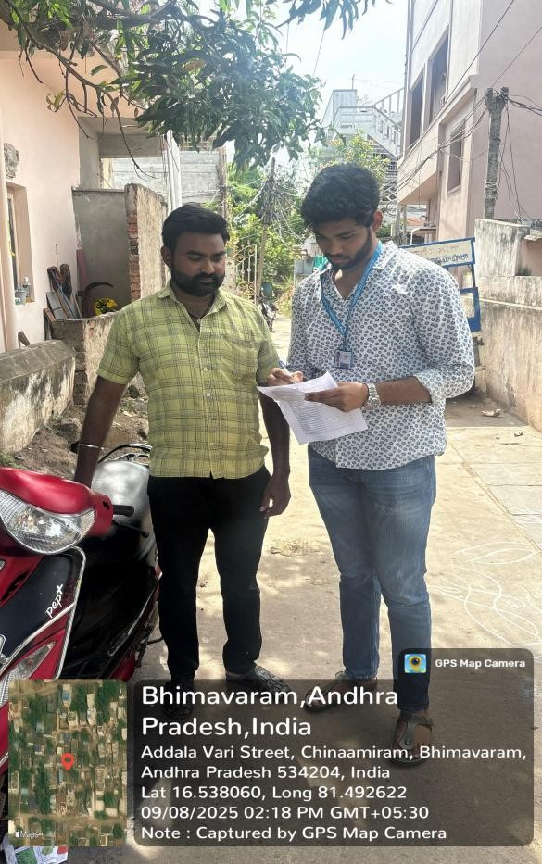
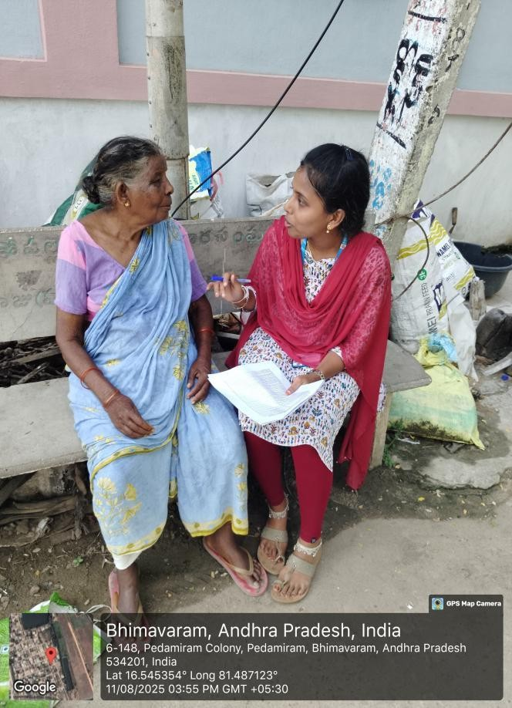

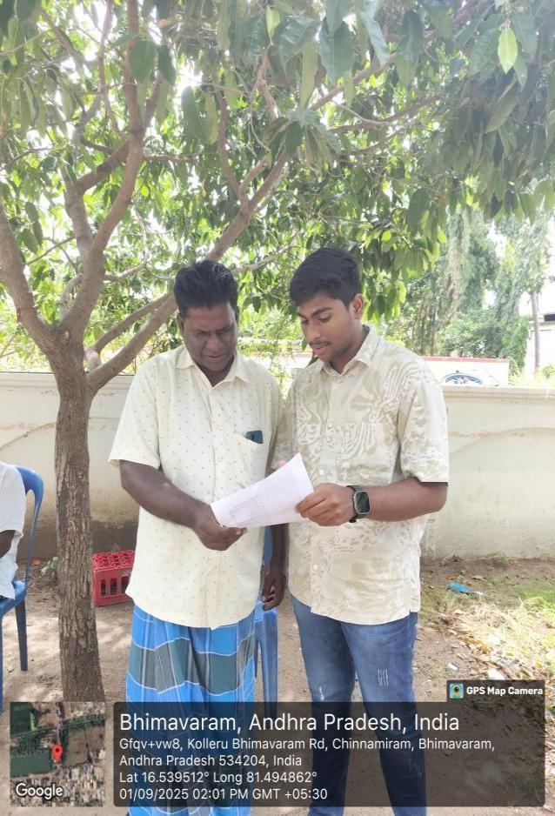
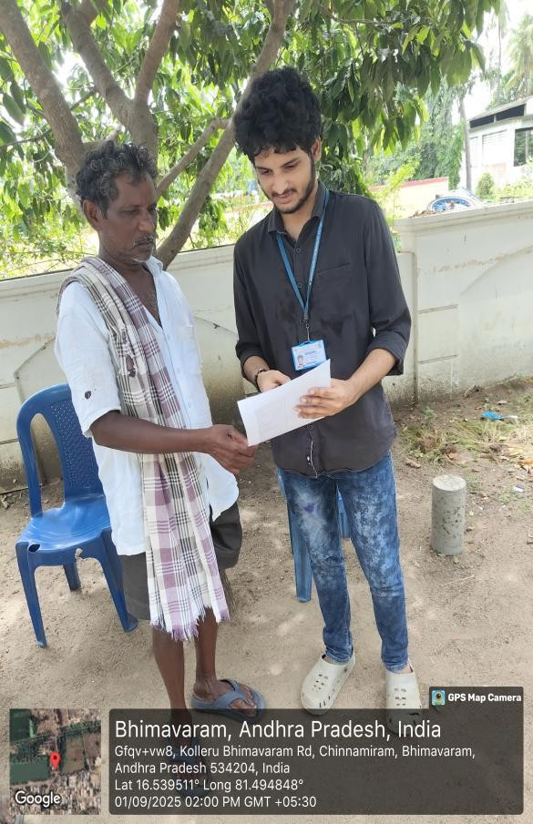

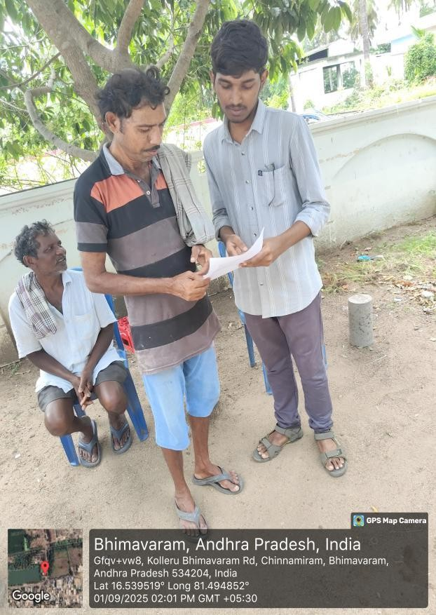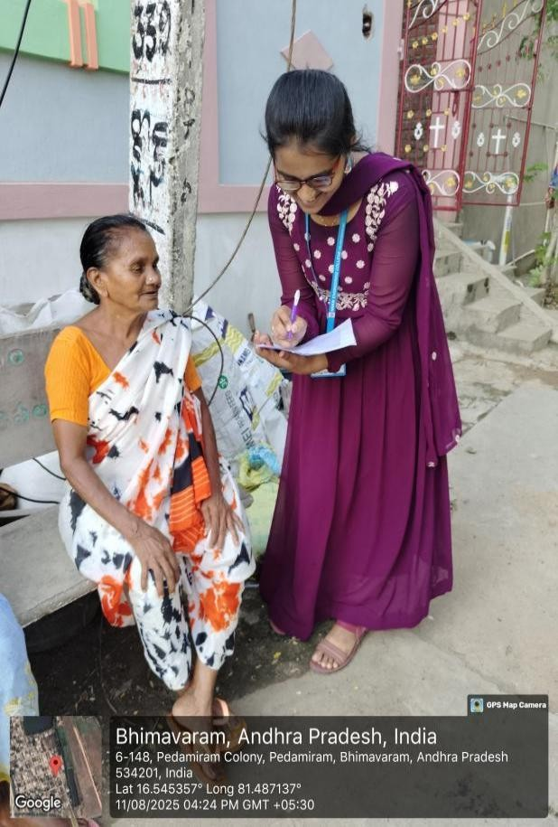

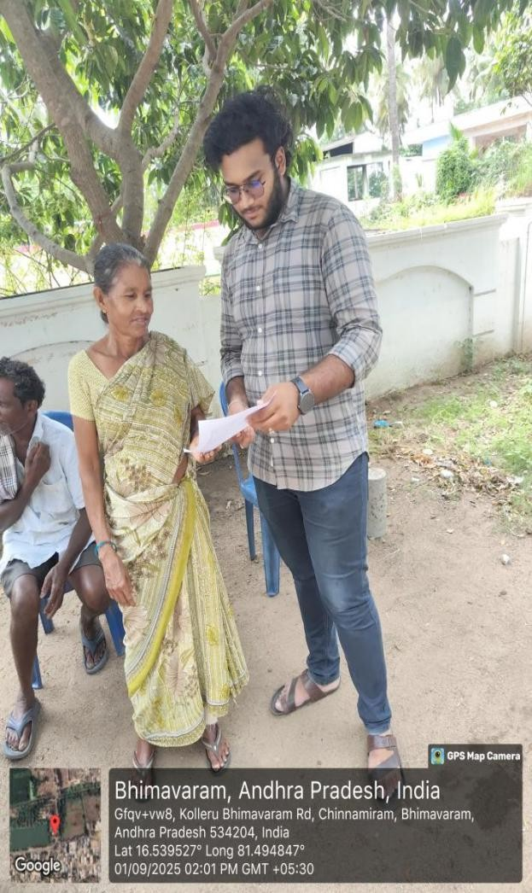
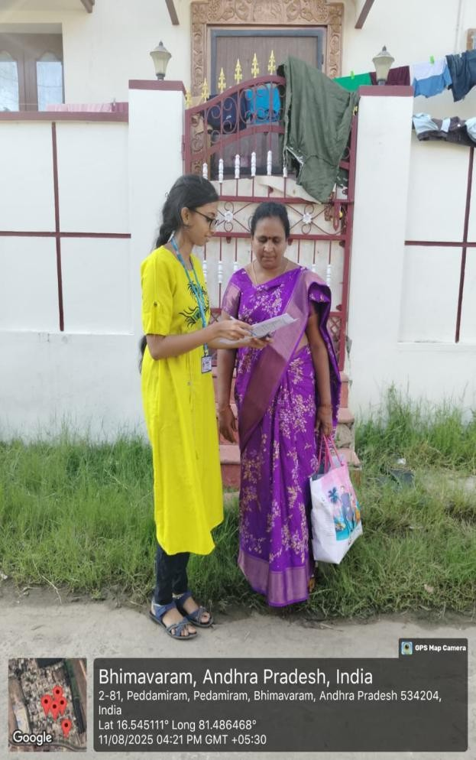

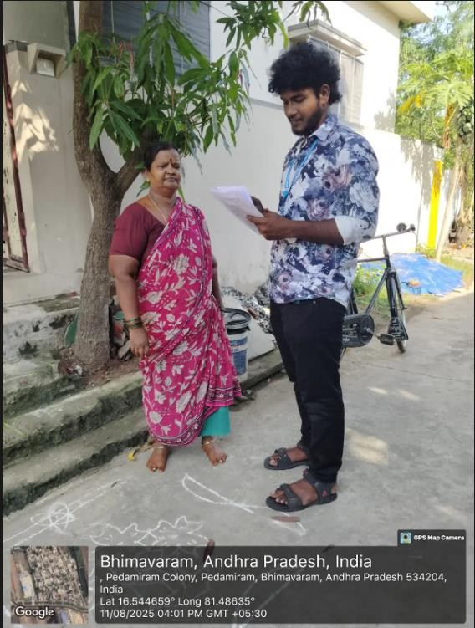
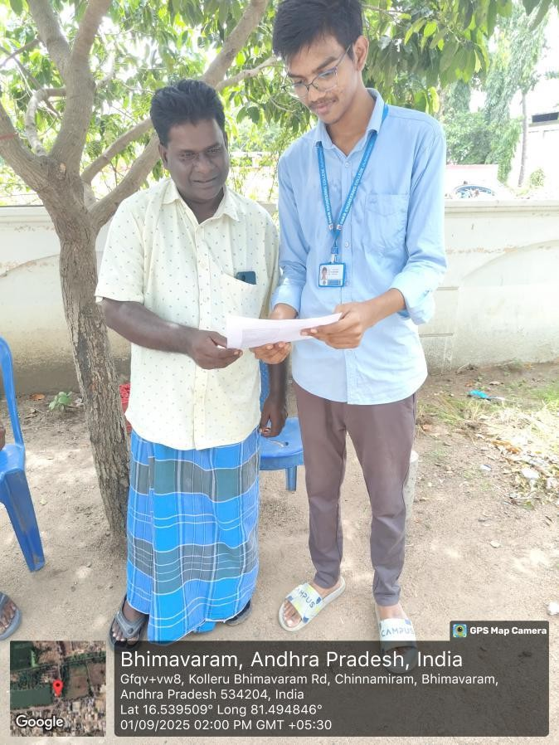
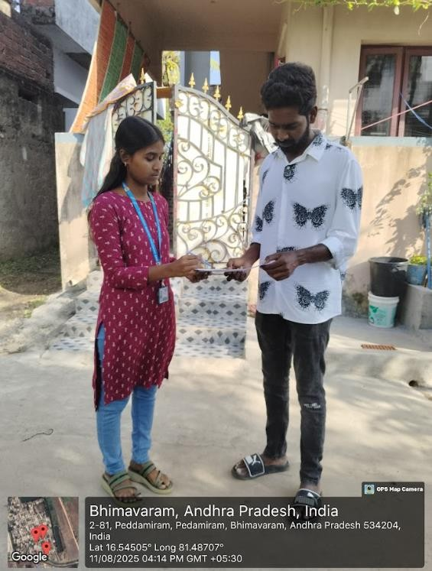

EVALUATION

MARKS STATEMENT
(To be used by the Examiners)

Name of the student: S. Guna Sekhar
Programme of Study: CSE
Year / Sem: 3/4 I sem
Register No/H.T. No: 23B91A05S3
Name of the College: SRKR Engineering College::Bhimavaram
University: Jawaharlal Nehru Technological University, Kakinada

Sl. No | Evaluation Criterion | Maximum Marks | Marks Awarded
1. | Project Log | 10
2. | Project Implementation | 15
3. | Project Report | 15
4. | Presentation & Viva-Voce | 10
 | GRANDTOTAL | 50

Date: Signature of the Faculty Guide

Certified by

Date: Signature of the HOD
Seal:

Name of the student: T. Kailash Prasanth
Programme of Study: CSE
Year / Sem: 3/4 I sem
Register No/H.T. No: 23B91A05S4
Name of the College: SRKR Engineering College::Bhimavaram
University: Jawaharlal Nehru Technological University, Kakinada

Sl. No | Evaluation Criterion | Maximum Marks | Marks Awarded
1. | Project Log | 10
2. | Project Implementation | 15
3. | Project Report | 15
4. | Presentation & Viva-Voce | 10
 | GRANDTOTAL | 50

Date: Signature of the Faculty Guide

Certified by

Date: Signature of the HOD
Seal:

Name of the student: T. Abhinav
Programme of Study: CSE
Year / Sem: 3/4 I sem
Register No/H.T. No: 23B91A05S5
Name of the College: SRKR Engineering College::Bhimavaram
University: Jawaharlal Nehru Technological University, Kakinada

Sl. No | Evaluation Criterion | Maximum Marks | Marks Awarded
1. | Project Log | 10
2. | Project Implementation | 15
3. | Project Report | 15
4. | Presentation & Viva-Voce | 10
 | GRANDTOTAL | 50

Date: Signature of the Faculty Guide

Certified by

Date: Signature of the HOD
Seal:

Name of the student: T. Sri Yashwanth Chowdary
Programme of Study: CSE
Year / Sem: 3/4 I sem
Register No/H.T. No: 23B91A05S6
Name of the College: SRKR Engineering College::Bhimavaram
University: Jawaharlal Nehru Technological University, Kakinada

Sl. No | Evaluation Criterion | Maximum Marks | Marks Awarded
1. | Project Log | 10
2. | Project Implementation | 15
3. | Project Report | 15
4. | Presentation & Viva-Voce | 10
 | GRANDTOTAL | 50

Date: Signature of the Faculty Guide

Certified by

Date: Signature of the HOD
Seal:

Name of the student: T. Rohith Programme of Study: CSE Year / Sem: 3/4 I sem
Register No/H.T. No: 23B91A05S7
Name of the College: SRKR Engineering College::Bhimavaram
University: Jawaharlal Nehru Technological University, Kakinada

Sl. No | Evaluation Criterion | Maximum Marks | Marks Awarded
1. | Project Log | 10
2. | Project Implementation | 15
3. | Project Report | 15
4. | Presentation & Viva-Voce | 10
 | GRANDTOTAL | 50

Date: Signature of the Faculty Guide

Certified by

Date: Signature of the HOD
Seal:

Name of the student: T.J.V. Sai Kumara Reddy
Programme of Study: CSE
Year / Sem: 3/4 I sem
Register No/H.T. No: 23B91A05S8
Name of the College: SRKR Engineering College::Bhimavaram
University: Jawaharlal Nehru Technological University, Kakinada

Sl. No | Evaluation Criterion | Maximum Marks | Marks Awarded
1. | Project Log | 10
2. | Project Implementation | 15
3. | Project Report | 15
4. | Presentation & Viva-Voce | 10
 | GRANDTOTAL | 50

Date: Signature of the Faculty Guide

Certified by

Date: Signature of the HOD
Seal:

Name of the student: T. Venkata Lakshmi
Programme of Study: CSE
Year / Sem: 3/4 I sem
Register No/H.T. No: 23B91A05S9
Name of the College: SRKR Engineering College::Bhimavaram
University: Jawaharlal Nehru Technological University, Kakinada

Sl. No | Evaluation Criterion | Maximum Marks | Marks Awarded
1. | Project Log | 10
2. | Project Implementation | 15
3. | Project Report | 15
4. | Presentation & Viva-Voce | 10
 | GRANDTOTAL | 50

Date: Signature of the Faculty Guide

Certified by

Date: Signature of the HOD
Seal:

Name of the student: T. Dattu Prasanna
Programme of Study: CSE
Year / Sem: 3/4 I sem
Register No/H.T. No: 23B91A05T0
Name of the College: SRKR Engineering College::Bhimavaram
University: Jawaharlal Nehru Technological University, Kakinada

Sl. No | Evaluation Criterion | Maximum Marks | Marks Awarded
1. | Project Log | 10
2. | Project Implementation | 15
3. | Project Report | 15
4. | Presentation & Viva-Voce | 10
 | GRANDTOTAL | 50

Date: Signature of the Faculty Guide

Certified by

Date: Signature of the HOD
Seal:

Name of the student: T.Navya Sri
Programme of Study: CSE
Year / Sem: 3/4 I sem
Register No/H.T. No: 23B91A05T1
Name of the College: SRKR Engineering College::Bhimavaram
University: Jawaharlal Nehru Technological University, Kakinada

Sl. No | Evaluation Criterion | Maximum Marks | Marks Awarded
1. | Project Log | 10
2. | Project Implementation | 15
3. | Project Report | 15
4. | Presentation & Viva-Voce | 10
 | GRANDTOTAL | 50

Date: Signature of the Faculty Guide

Certified by

Date: Signature of the HOD
Seal:

Name of the student: T.Praveena Niharika
Programme of Study: CSE
Year / Sem: 3/4 I sem
Register No/H.T. No: 23B91A05T2
Name of the College: SRKR Engineering College::Bhimavaram
University: Jawaharlal Nehru Technological University, Kakinada

Sl. No | Evaluation Criterion | Maximum Marks | Marks Awarded
1. | Project Log | 10
2. | Project Implementation | 15
3. | Project Report | 15
4. | Presentation & Viva-Voce | 10
 | GRANDTOTAL | 50

Date: Signature of the Faculty Guide

Certified by

Date: Signature of the HOD
Seal:

Name of the student: T.S.S.Ravi Lokesh
Programme of Study: CSE
Year / Sem: 3/4 I sem
Register No/H.T. No: 23B91A05T3
Name of the College: SRKR Engineering College::Bhimavaram
University: Jawaharlal Nehru Technological University, Kakinada

Sl. No | Evaluation Criterion | Maximum Marks | Marks Awarded
1. | Project Log | 10
2. | Project Implementation | 15
3. | Project Report | 15
4. | Presentation & Viva-Voce | 10
 | GRANDTOTAL | 50

Date: Signature of the Faculty Guide

Certified by

Date: Signature of the HOD
Seal:



